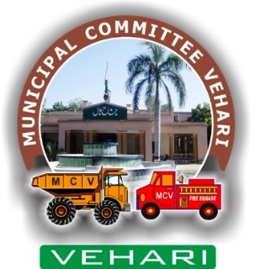

Annual Report

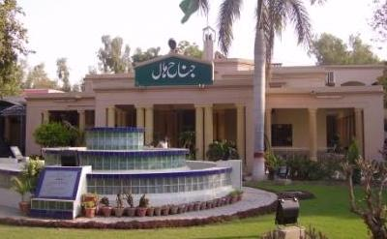

*Vehari is one of the three Tehsils of district Vehari. It spreads over an area of 1,430 square kilometers with a population of 654,955*

*Tehsil Vehari borders with Bahawalnagar and Bahawalpur on the Southern side, with Pakpattan on the eastern, with Khanewal and Lodhran on western and with Sahiwal and Khanewal on northern side.*

**2019-20**

**Municipal Committee Vehari**

Table of Contents

1. Background: 1

2. Map of City Vehari: 1

3. Functions of Municipal Committee Vehari 1

4. Human Resource at MC: 2

4.1. Municipal Committee Organogram 2

4.2. Administrative Setup 2

4.3. Human resource Available at MC 3

5. Annual Budget: 4

5.1. Development expenditure 4

6. Development Projects 5

7. Municipal Services Delivery Detail 5

7.1. Water supply system 5

7.1.1. Water supply hours 5

7.1.2. Total coverage of the city 5

7.1.3. Tariff Structure 6

7.1.4. Water filtration plants: 6

7.1.5. The water quality & causes of shortage of water 7

7.1.6. Man power deployment 7

7.2. Solid Waste Management 8

7.2.1. Solid waste Generation & Disposal 8

7.2.2. Equipment & Machinery 8

7.2.3. ManpowerDeployed 9

7.2.4. Coverage Detail 9

7.2.5. Landfill development 11

7.2.6. Vehicle parking Area: 11

7.2.7. Levying of sanitation fees 11

7.3. Solid waste management financials (million Rs) 11

7.4. Sewerage 11

7.4.1. Coverage 11

7.4.2. Existing pumping / disposal stations 12

7.4.3. Sucker & jetting machines 13

7.4.4. Man power deployed 13

7.4.5. Tariff structure 13

7.4.6. Drainage zones 14

7.4.7. Sewer lengths 15

7.5. Streetlight 15

7.5.1. Streetlights on Major roads: 15

7.5.2. Ward wise detail of existing streetlights 15

7.5.3. Expenditure on streetlights 16

8. Complaint Management 17

9. MC Website (www.mcvehari.lgpunjab.org.pk) 17

10. MC Response to the Requests of Citizens under RTI Act 2013 17

Annex A 19

Annex B 22

Annex C 27

**Foreword:**

On behalf of the Municipal Committee Vehari, I hereby present this Annual Report for the financial year 2019-20. The report will give our stakeholders and communities an insight into the performance and achievements of the Municipal Committee. The current Annual Report outlines MCs successes and shortcomings in relation to our mandate as provided in the key focus areas of Local Governments. These can be summarized as; Building a Municipal Corporation that is efficient, effective and responsive; Strengthen Accountability and promote fairness in its dealings; Accelerating Service Delivery and supporting the vulnerable; Promoting Economic and Social development; Fostering Development Partnerships, Social Cohesion and Community Uplift Programs. It is pertinent to note that these endeavors’ can never be successfully achieved on their own but it becomes materialized by the collective efforts of officers, officials and support staff who work together in identifying challenges and to meet those challenges with rigor efforts and earnest professional approach.

It is commendable to note the improvements in relation to our spending and expenditure patterns, but we need to do more. The ever present excuse of lack of resource might be a legitimate one, but the key question is how effectively we use the resources at our disposal to accomplish our goals and attaining set targets. It is clear in this annual report that we are moving in the right direction. It is of paramount importance to synchronize our program plans with quarterly targets to achieve our broader goals effectively and efficiently.

**Administrator**

**Municipal Committee**

**Vehari**

# **Background:**

The city of Vehari is the administrative headquarters of [Vehari](https://en.wikipedia.org/wiki/Burewala_Tehsil) District. The district was created on 1st July 1976 comprising of the three former tehsils of [Multan District](https://en.wikipedia.org/wiki/Multan_District) ([Vehari](https://en.wikipedia.org/wiki/Vehari), [Burewala](https://en.wikipedia.org/wiki/Burewala) and [Mailsi](https://en.wikipedia.org/wiki/Mailsi)). The name Vehari means low-lying settlement by a flood water channel. The district lies along the right bank of the River [Sutlej](https://en.wikipedia.org/wiki/Sutlej), which forms its southern boundary. Vehari is known to be a city of [cotton](https://en.wikipedia.org/wiki/Cotton), among other crops and has dozens of cotton processing factories &[cottonseed oil](https://en.wikipedia.org/wiki/Cottonseed_oil) manufacturing plants along with [sugarcane](https://en.wikipedia.org/wiki/Sugarcane) farming and processing. Fruits grown over here include [mangoes](https://en.wikipedia.org/wiki/Mango) in the summer and [guava](https://en.wikipedia.org/wiki/Guava) and other citrus fruits in the winter.

Vehari city is located at 100 km (62 miles) distance from the historical city of [Multan](https://en.wikipedia.org/wiki/Multan) in the east at old Multan-Delhi Road constructed by Indian Muslim Emperor [Sher Shah Soori](https://en.wikipedia.org/wiki/Sher_Shah_Suri" \o "Sher Shah Suri) and is the headquarters of [Vehari District](https://en.wikipedia.org/wiki/Vehari_District). It is located at 300 02’ N and 720 21’E and connected with all cities through rail and road

The climate in Vehari is called a desert climate. July & August are hottest months when the temperatures generally reaches to 45°C and in night the average minimum temperature drops down to 28°C. The average humidity of city in August is 72%

Winter season starts from November and lasts till February. Mean maximum and minimum temperatures recorded during the month of January are about 21 and 5 degree Celsius respectively.

As per provisional statistics of Population census 2017, the population of Vehari city has been observed to be 112,840 persons in 2018. However the city had a population of 170,330 persons as per Land Scan exercise run in 2015 and projected up to 2017 at an annual growth rate of 3.36%. The population will rise to 237,037 persons in the year 2027 with this growth rate. It means that some inhabited areas of the city have not been included in the municipal limits which need to be extended by taking all the populated areas in the city limits.

**Economic Activities in the City**

Vehari is a rich agricultural land. The major profession of the people of **Vehari** is agriculture. The major crops are Wheat, Groundnut, Maize and all kinds of vegetables. However, almost 10- 20 % people are job workers or running their own businesses. The Vehari has following major industry;

* Handicrafts
* Chemical Industry
* Ginning Mills
* Agro Based Industry
* Shoe Industry
* Pesticides
* Pharmaceuticals
* Packaging Industry
* Storage Industry
* Paper Industry
* Flour Mills
* Plastic Products
* Textile
* Cold Storage
* Warehouse

# **Map of City Vehari**:

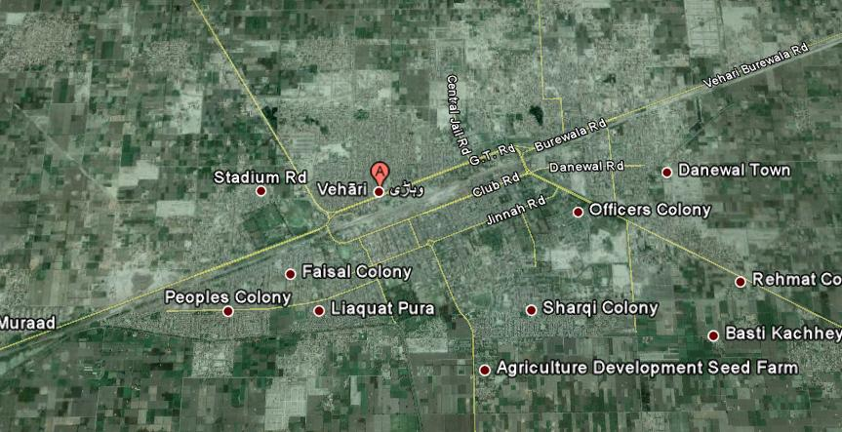

# **Functions of Municipal Committee Vehari**

Municipal Committee Vehari is responsible for performing the following functions as per new PLGA 2019:

1. Economic and value chain development;
2. Management of primary, elementary and secondary education facilities;
3. School enrolment and universal education;
4. Monitoring and supervision of primary health care facilities;
5. Preventive health and hygiene;
6. Population welfare including population control;
7. Solid waste collection and disposal;
8. Sewerage collection and disposal including water management and treatment;
9. Building control and land use;
10. Births, deaths, marriages and divorce registration;
11. Museums and art galleries;
12. Open markets;
13. Livestock and agriculture markets;
14. Public parking facilities;
15. City roads and traffic management & Public transport;
16. Abstraction of water for industrial and commercial purposes;
17. Emergency planning and relief;
18. Support to provincial agencies in prevention of crime and maintenance of public order; and
19. Regulatory enforcement in the functions
20. Establishment and management of pre-schools & Libraries;
21. Drinking water supply;
22. Burials, cremations etc.;
23. Public conveniences;
24. Children's services 7 Community safety;
25. Arts and recreation &Public fairs and ceremonies & Sports
26. Environmental health, awareness and services;
27. Parks and landscape development;
28. Slaughtering of animals;
29. Street lights; and Sign boards and street advertisements.

# Human Resource at MC:

## Municipal Committee Organogram

## Administrative Setup

|  |  |
| --- | --- |
| **Administrator**  **Capt. (R) Waqas Rashid T. Bt, PAS**  ***Date of Joining: 02-11-2019***  **067-3361308** | http://www.mcvehari.lgpunjab.org.pk/images/MC-office/Waqas-rasheed-dc.jpeg |
| **Chief Officer**  **Rao Muhammad Naeem Khalid**  **Date of Joining: 19-08-2020**  **Ph. No.0300-7734922** |  |
| **Municipal Officer (Regulation)**  **Arham Nazir**  **Date of Joining: 01-06-2020**  **Ph. No.0300-4208177** |  |
| **Municipal Officer (Finance)**  **Rana Khalil Ahmad**  **Date of Joining: 10-12-2018**  **Ph. No.0302-7316590** | http://www.mcvehari.lgpunjab.org.pk/images/MC-office/Rana-Khalil-MOF.jpeg |
| **Municipal Officer (Infrastructure & Services)**  **Muhammad Uzair Arshad**  **Date of Joining: 11-06-2020**  **Ph. No.0322-3322164** |  |
| **Municipal Officer (Planning)**  **Muhammad Umar Farooq**  **Date of Joining:07-03-2020**  **Ph. No. 0300-4371720** |  |

## Human resource Available at MC

|  |  |  |  |
| --- | --- | --- | --- |
| Vacancy Analysis-Section Wise | | | |
| Section | **Sanctioned** | **Filled** | **Vacant** |
| Chairman | 4 | 4 | 0 |
| Vice Chairman | 1 | 1 | 0 |
| Chief Officer | 17 | 15 | 2 |
| Municipal Officer (F) | 18 | 14 | 4 |
| Municipal Officer (R) | 17 | 10 | 7 |
| Municipal Officer (P) | 10 | 8 | 2 |
| Municipal Officer (I&S) | 493 | 320 | 173 |
| Total | **560** | **372** | **188** |

MC schedule of establishment is attached as Annex - A

# **Annual Budget:**

|  |  |  |  |  |  |  |  |  |  |  |  |  |  |  |  |  |  |  |  |  |  |  |  |  |  |  |  |  |  |  |  |  |  |  |  |  |  |  |  |  |  |  |  |  |  |  |  |  |  |  |  |  |  |  |  |  |
| --- | --- | --- | --- | --- | --- | --- | --- | --- | --- | --- | --- | --- | --- | --- | --- | --- | --- | --- | --- | --- | --- | --- | --- | --- | --- | --- | --- | --- | --- | --- | --- | --- | --- | --- | --- | --- | --- | --- | --- | --- | --- | --- | --- | --- | --- | --- | --- | --- | --- | --- | --- | --- | --- | --- | --- | --- |
| |  |  |  |  |  |  |  |  |  |  |  |  |  |  |  |  |  |  |  |  |  |  |  |  |  |  |  |  |  |  |  |  |  |  |  |  |  |  |  |  |  |  |  |  |  |  |  |  |  |  |  |  |  |  |  |  | | --- | --- | --- | --- | --- | --- | --- | --- | --- | --- | --- | --- | --- | --- | --- | --- | --- | --- | --- | --- | --- | --- | --- | --- | --- | --- | --- | --- | --- | --- | --- | --- | --- | --- | --- | --- | --- | --- | --- | --- | --- | --- | --- | --- | --- | --- | --- | --- | --- | --- | --- | --- | --- | --- | --- | --- | | |  |  |  |  |  | | --- | --- | --- | --- | --- | | Abstract of annual budget of Municipal Corporation Vehari is as under:  Financial Position 2018-19 | | | | | |  | **Actual**  **2017-18** | **Estimated 2018-19** | **Actual**  **2018-19** | **Estimated**  **2019-20** | | Opening Balance as on July 1st. | 136,756,425 | 100,000,000 | 91,546,551 | 100,000,000 | | Income | 106,712,246 | 161,382,000 | 122,866,305 | 171,265,000 | |  | 133,303,220 | 244,265,584 | 154,329,400 | 237,033,000 | | Total Receipts | **376,771,891** | **505,647,584** | **368,742,256** | **508,298,000** | | Expenditure | 235,073,799 | 390,537,800 | 269,976,440 | 415,460,000 | |  | 16,150,796 | 70,796,250 | 1,785,815 | 40,455,000 | |  | 26,814,917 | 11,528,500 | 5,717,267 | 26,550,000 | | Total Expenditure | **278,039,512** | **472,862,550** | **277,479,522** | **482,465,000** | | Closing balance as on June 30th. | 98,732,379 | 32,785,034 | 91,262,734 | 25,833,000 | |   The income & expenditure statements are attached as Annex - A |

## Development expenditure

The expenditure incurred on the development projects fromyear2013-14 to the current financial year & source of financing is given below

***(All figures in million Rs)***

|  |  |  |  |  |  |  |  |  |
| --- | --- | --- | --- | --- | --- | --- | --- | --- |
| Description | 2013-14 | 2014-15 | 2015-16 | | 2016-17 | | 2017-18 | 2018-19 |
| Expenditure on Development Projects | 21.703 | 2.903 | 134.351 | 73.957 | | 46.503 | |  |
| Source of Financing of Development Projects | Own source revenue | ADP grants | PFC share | PPP | | Others (Specify) | |  |
| √ | - | √ | - | | - | |  |
| Expenditure on O&M of services and revenue generated | | | | | | | |  |
| Water supply | | | | | | | |  |
| Total O&M cost | 32.1 | 39.94 | 38.11 | 31.14 | | 38.32 | |  |
| Revenue earned | 1.08 | 0.86 | 0.49 | 0.73 | | 2.11 | |  |
| % revenue earned vs O&M charges | 3.36% | 2.15% | 1.29% | 2.34% | | 5.51% | |  |
| Subsidy injected | **31.02** | **39.08** | **37.62** | **30.41** | | **36.21** | |  |
| Sewerage/drainage | | | | | | | |  |
| Total O&M cost | 20.161 | 21.967 | 16.104 | 9.958 | | 16.575 | |  |
| Revenue earned | 0.016 | 0.021 | 0.044 | 0.015 | | 0.062 | |  |
| Subsidy injected | **20.145** | **21.946** | **16.06** | **9.943** | | **16.513** | |  |
| Solid waste management | | | | | | | |  |
| O&M cost | 39.898 | 42.864 | 50.238 | 58.333 | | 69.062 | |  |
| Revenue earned | Nil | Nil | Nil | Nil | | Nil | |  |
| Subsidy injected | **39.898** | **42.864** | **50.238** | **58.333** | | **69.062** | |  |
| Parks | | | | | | | |  |
| O&M cost | 6.044 | 5.369 | 4.769 | 3.336 | | 5.020 | |  |
| Revenue earned | Nil | Nil | Nil | Nil | | Nil | |  |
| Subsidy injected | **6.044** | **5.369** | **4.769** | **3.336** | | **5.020** | |  |
| Slaughter houses | | | | | | | |  |
| O&M cost | 0.423 | 0.457 | 0.512 | 0.310 | | 0.204 | |  |
| Revenue earned | 0.022 | 0.220 | 0.681 | 0.291 | | 0.554 | |  |
| Subsidy injected (-) Income (+) | 0.401 | 0.237 | -0.169 | 0.019 | | -0.350 | |  |
| Street Light | | | | | | | |  |
| Total Expenditure | 10.699 | 11.177 | 8.160 | 10.481 | | 12.240 | |  |
| Revenue earned | The service is not charged. | | | | | | |  |

1. Development Projects

The Annual Development Plan initiated by Municipal Committee vehari in the current and preceding years is as under:

|  |  |  |  |  |
| --- | --- | --- | --- | --- |
| Summary of ADP Projects of Municipal Committee Vehari | | | | |
| Sr. No | **Financial Year** | **No. of Total Projects** | **Approved Cost(PKR)** | **Status** |
| 1 | 2017-18 | 26 | 24.09 | completed |
| 2 | 2018-19 | 7 | 23.25 | completed |
| 3 | 2019-20 | 33 | 57.41 | completed |

List of Approved Projects of Municipal Committee, Vehari is attached at Annex-C

# Municipal Services Delivery Detail

## Water supply system

### **Water supply hours**

On an average MC is supplying 02 hours of water to households daily as per given schedule

|  |  |  |  |  |
| --- | --- | --- | --- | --- |
| Water supplied hours | | | | |
| **Early Morning** | **Morning** | **Midday** | **Evening** | **Total** |
| **0.5** | **0.5** | **0.5** | **0.5** | **2.0** |

### Total coverage of the city

The total area coverageofwatersupplyinthecityis57%outofwhich6%areafallsunder water shortage and 13%underthewater contamination. Rest of43% area is un-served. The detail of water connections and percent connected are given as under;

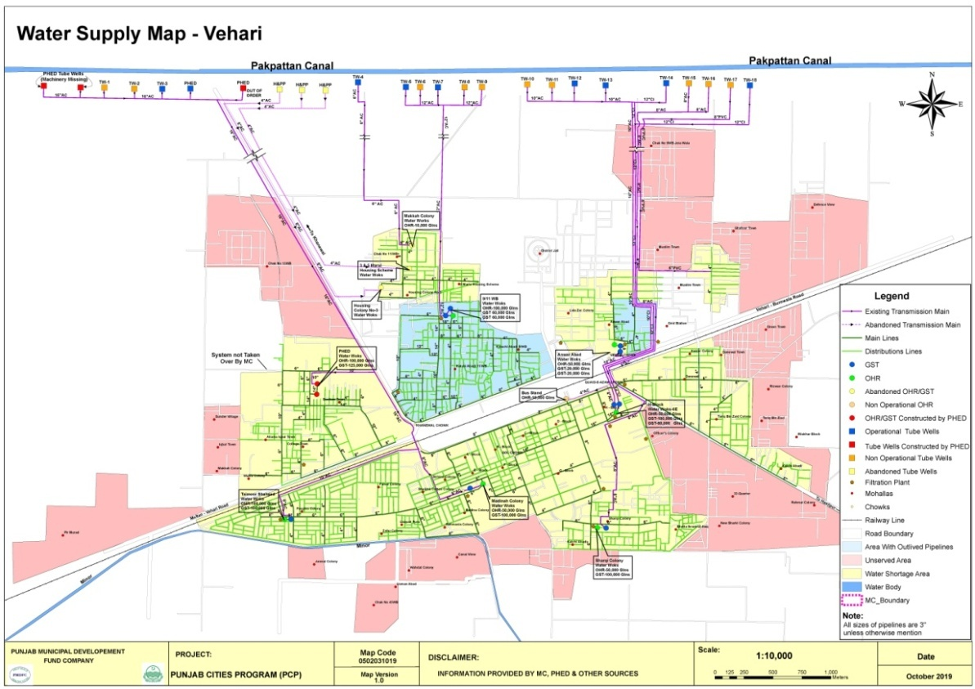

|  |  |  |  |  |
| --- | --- | --- | --- | --- |
| No. of connections | | | | %age connected |
| **Domestic** | **Commercial** | **Industrial** | **Total** |
| 6304 | 120 | - | 6424 | 11% |

The water supply hours are very short and the water shortage prevails at remote ends of the distribution system because of unequal distribution of water in the absence of consumer metering.

### Tariff Structure

The consumer’s connections are not metered and hence water. The water rates are given below;

|  |  |  |
| --- | --- | --- |
| Tariff Rates per month | | |
| **Domestic** | **Com.** | **Ind.** |
| Rs. 50 | Rs. 200 | 2500 |

### Water filtration plants:

Total 19 filtration plants are being maintained by MC in the city to supply potable water to the in habitants. All are working in good condition and no need for repair of its component to supply potable water to the in habitants of the city.

### The water quality & causes of shortage of water

Deep tube wells have been installed along the Pakpattan Canal which has been remodeled by reducing its discharge. As such very little seepage from the canal is intercepted by these tube wells and hence the quality of these tube wells has deteriorated. The tube wells are pumping into six intermediate pumping stations in the city and water has varying TDS value from 305 ppm to 1045 ppm.

The source at Pakpattan Canal cannot afford installation of additional tube wells and some other fresh water aquifer around the city will have to be tapped to supply fresh water to the city residents. To fight the water shortage on urgency basis replacement and repair of tube well is required.

Main and the only reason for water shortage is the scarcity of fresh water in and around the city. Sub soil water in the city is brackish and unfit for human consumption and hence water has to be imported in the city from some fresh water zone. Unless a comprehensive scheme for tapping the fresh water is planned and launched, the water shortage cannot be addressed

Lot of water wastage is occurring in the water supply system in below given ways;

1. Some consumer connections have no taps.
2. Some consumers keep the taps open in all water supply hours although they do not need water.
3. Most of the overhead tanks of the consumers have no float valve and when their tank is full, the water flows down to the drains continuously during the supply hours.

The water wastage requires excessive water production and high electricity consumption. It is exerting a large pressure on the municipal budget. Large savings in the electricity bills and ultimately the O&M cost, can be affected by reducing the water wastage at the consumer ends. It will save lot of water and water shortage can be addressed by conservation of water being wasted at present. The best and efficient way to save water and reduce O&M cost is the consumer metering.

### Man power deployment

|  |  |  |  |  |  |  |
| --- | --- | --- | --- | --- | --- | --- |
| Slot | Sanctioned strength | Existing strength | Vacant post | Manpower on daily wages | Total man power deployed | Additional  MCdemand |
| Tube-well operators | 31 | 24 | 7 | 0 | 24 | 40 |
| Chowkidars | 3 | 2 | 1 | 0 | 2 | 10 |
| Electricians | 0 | 0 | 0 | 0 | 0 | 5 |
| Plumbers | 1 | 0 | 1 | 0 | 0 | 10 |
| Plumberhelpers | 0 | 0 | 0 | 0 | 0 | 5 |
| Fitter Quli | 3 | 3 | 0 | 0 | 3 | 10 |
| Baildar | 6 | 5 | 1 | 0 | 5 | 10 |
| Water Superintendent | 1 | 1 | 0 | 0 | 1 | 1 |
| Total | 45 | 35 | 10 | 0 | 35 | 91 |

The vacant positions of the field staff need to be filled for satisfactory service delivery.

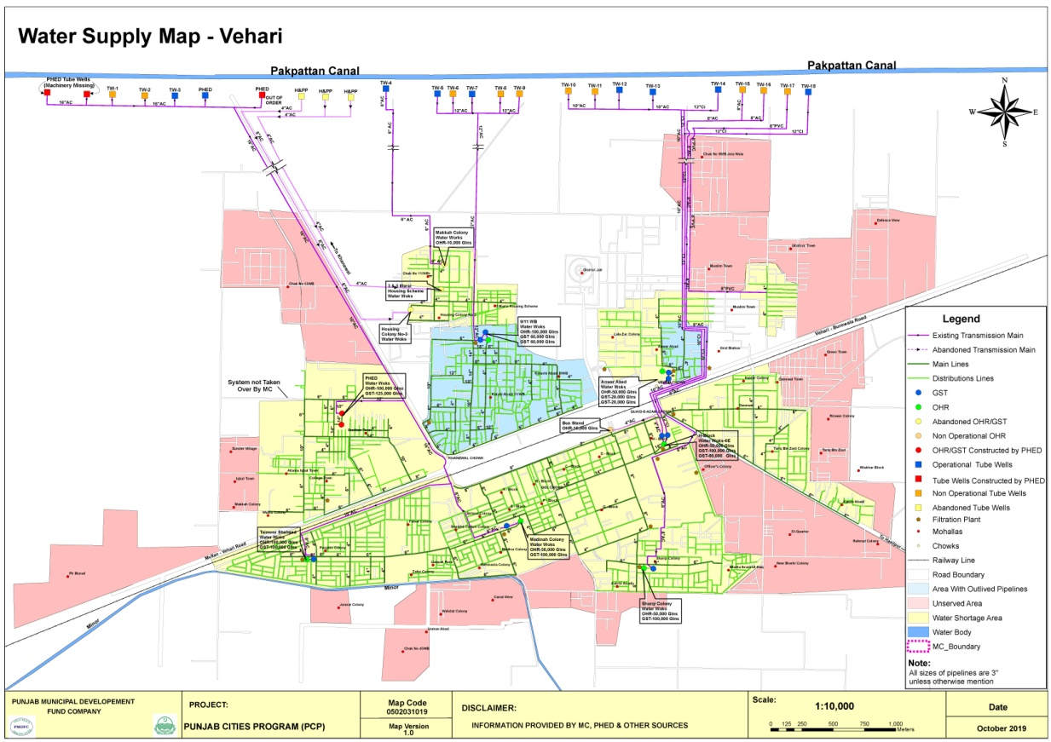

## Solid Waste Management

### Solid waste Generation & Disposal

The solid waste management efficiency along with present dumping sites is given below;

|  |  |
| --- | --- |
| Total waste generated | 63.5 Tons |
| Waste disposal | 47.95 Tons |
| % age efficiency | 75 % |

### Equipment & Machinery

Under mentioned collection and transportation machinery is available with MC to handle the solid waste.

|  |  |  |  |  |
| --- | --- | --- | --- | --- |
| S.N | Equipment/machinery | Total available  Nos. | Working | Requiring repair (Nos.) |
| 1 | Tractor trolleys | 3 | 3 | - |
| 2 | Arm roll truck | 1 | 1 | - |
| 3 | 5.0 m3 containers | 10 | 10 | - |
| 4 | Garbage dumpers | - | - | - |
| 5 | Front blade tractors | 1 | 1 | 1 |
| 6 | Front end loaders | 3 | 3 | - |
| 7 | Water bouzers | 3 | 3 | - |
| 9 | Mechanical sweepers | 1 | 1 | - |

The existing machinery is neither sufficient nor cost effective and efficient giving rise to low efficiency of collection and disposal of the waste and as a result of that MC is facing higher waste management cost as well as complaints regarding the insanitary conditions in the city. Efficient and cost effective machinery is needed to increase the efficiency of collection and transportation for improving the sanitary conditions and lowering down the operational and maintenance costs.

### Manpower Deployed

The manpower deployed for collection, transportation and disposal of the solid waste is given in the table below. As indicated by MC Officers, this manpower is not sufficient to serve the entire city at the given standards. Additional manpower required by the MC is also given here. Actual requirement will be identified after detail design and implementation of the project.

|  |  |  |  |  |  |  |
| --- | --- | --- | --- | --- | --- | --- |
| Slot | Sanctioned strength | Existing strength | Vacant posts | Manpower ondaily wages | Totalman power deployed | Additional  MCdemand |
| Sanitary workers | 198 | 151 | 47 | 27 | 178 | 150 |
| Vehicle drivers | 18 | 3 | 15 | 0 | 3 | 5 |
| Supervisors | 7 | 2 | 5 | 0 | 2 | 10 |
| Sanitary inspectors | 0 | 0 | 0 | 0 | 0 | 5 |
| Clerk | 1 | 0 | 1 | 0 | 0 | 4 |
| Other | 0 | 0 | 0 | 0 | 0 | 0 |
| Total | 224 | 156 | 68 | 27 | 183 | 174 |

### Coverage Detail

The entire city is not served with solid waste collection and disposal. 35% area of the city is fully served, 40% is partially served and 25% is un-served as marked on the map. In partially served areas service is rendered intermittently depending upon availability of manpower and transportation machinery. The detail of these areas is given below.

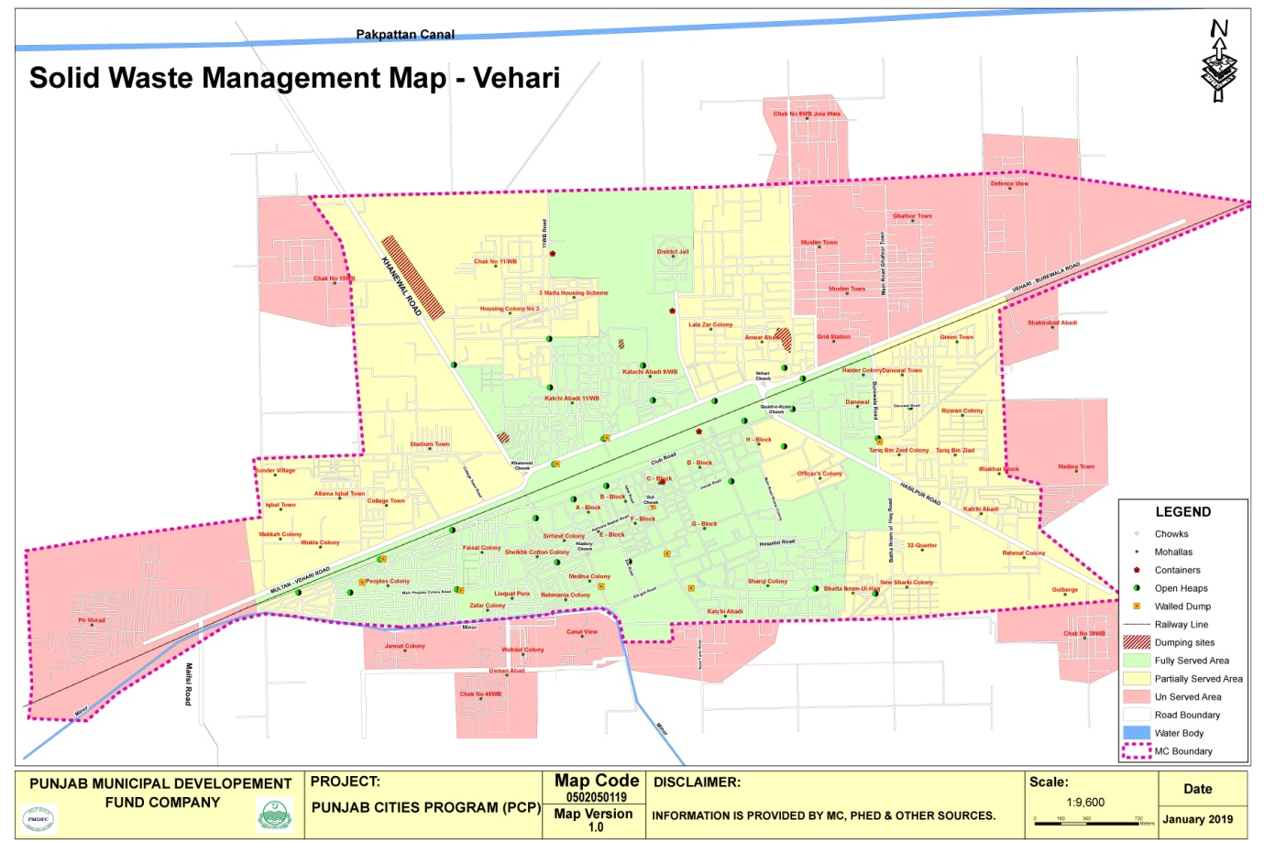

**a) Partially served areas**

No regular service is rendered in the under mentioned areas. The main complaints are attended by sending the machinery & labor once or twice a week.

|  |  |  |  |  |  |
| --- | --- | --- | --- | --- | --- |
| 1 | BhattaIkramulHaq | 2 | New Sharqi Colony | 3 | 32-Quarter |
| 4 | Rehmat Colony | 5 | KachiAbadi | 6 | Iftikhar Block |
| 7 | Tariq Bin Zaid | 8 | Officers Colony | 9 | Danewal Town |
| 10 | Green Town | 11 | Anwar Abad | 12 | Lalazar Colony |
| 13 | 3-Marla Scheme | 14 | Housing Scheme No.3 | 15 | Chak No. 11/W.B |
| 16 | Stadium town | 17 | College Town | 18 | AllamaIqbal Town |
| 19 | Wukla Colony | 20 | Gulberg | 21 | Madina town |
| 22 | Makkah colony | 23 | Sunder village | 24 | Chak no 13 WB |

1. **Unserved areas**

Under mentioned areas are still un-served;

|  |  |  |  |  |  |
| --- | --- | --- | --- | --- | --- |
| 1 | Defence View Society | 2 | Ghafoor Town | 3 | Muslim Town |
| 4 | Grid station | 5 | PirMurad Colony | 6 | Chak No. 9/W.B |
| 7 | Wahadat colony | 8 | Usmanabad | 9 | Peoples Colony (partly) |
| 10 | Chak No. 39/W.B | 11 | Canal View | 12 | Jannat Colony |
| 13 | Chak no 45 W.B | 14 | Madina town | 15 | Shabirabad |

### Landfill development

Approximate area of 10 acres will be required for the next 10 years for construction of landfills for safe and sanitary disposal of the solid waste of the city. Presently the waste is being dumped in 9-11/W.B, Khanewal road &KachiAbadi 9-11/W.B. MC is trying to procure 10 Acres land in surroundings of Vehari city for landfill. The suitability of the landfill site will be determined after detailed surveys and design of the project by catering the requirement of the environmental standards in vogue in Punjab.

### Vehicle parking Area:

MC has small but covered built-up parking area at present and the vehicles are parked in this area. It is located in G-Block and has an area of approximately 0.5 Acre. This space is required to be converted in to proper parking area by construction of parking sheds, vehicles washing and service arrangements, small office and other allied facilities.

### Levying of sanitation fees

No sanitation fee has been levied by MC and the entire expenditure given below is being met from MC’s own resources and the PFC share being given by Provincial government.

## Solid waste management financials (million Rs)

|  |  |  |  |  |  |  |
| --- | --- | --- | --- | --- | --- | --- |
| **Year** | **2013-14** | **2014-15** | **2015-16** | **2016-17** | **2017-18** | **2018-19** |
| O&M Expenditure | 39.898 | 42.864 | 50.238 | 58.333 | 69.062 |  |
| Sanitation fee/month per house hold | Nil | Nil | Nil | Nil | Nil |  |
| Subsidy injected | 39.898 | 42.864 | 50.238 | 58.333 | 69.062 |  |

## Sewerage

### **Coverage**

The city has 70% coverage of sewerage system but only the main and branch sewers have been laid and the lateral sewers have been provided in small area of the city.

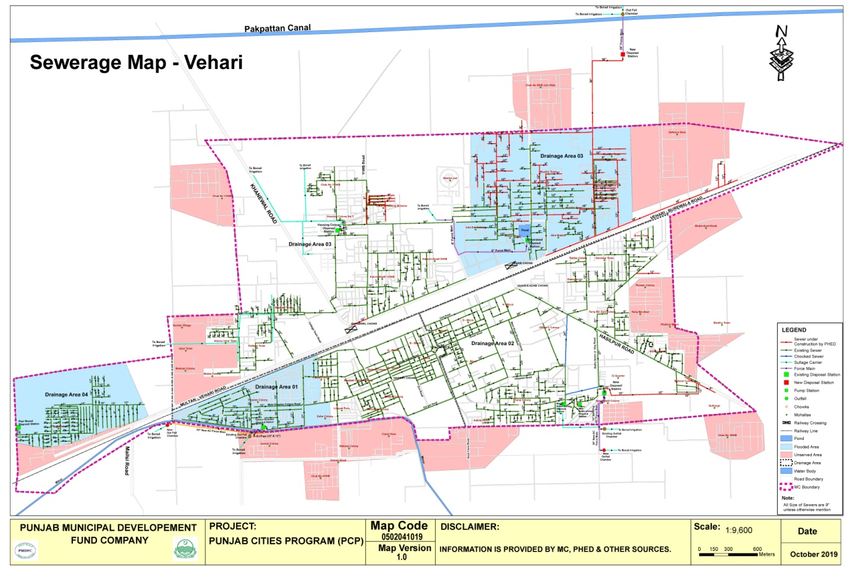

### **Existing pumping / disposal stati**ons

The detail of each pumping station already working in the city is given below;

|  |  |  |  |  |  |  |  |  |  |  |
| --- | --- | --- | --- | --- | --- | --- | --- | --- | --- | --- |
| **Location** | **Nos of collect. tanks** | **Nos of pumps** | **Discharge each (cusecs)** | **Total discharge (cusecs)** | **Motor BHP** | **working status** | **Force main/S. Carrier** | | | **Ultimate disposal** |
| **Size** | **Length** | **Condition** |
| Anwar abad | 1 | 1 | 1.0 | 1.0 | 20 | working | 9” dia | 1.5km | Good | Broad irrigation |
| BhattaIkramulHaq (main) | 2 | 3 | 2.0 | 6.0 | 40 | 01 No working | 12” RCC pipe & SC | 1.0 km | poor | do |
| BhattaIkmraulHaq mini | 1 | 1 | 1.0 | 1.0 | 20 | working | 6” dia | 0.18km | Good | do |
| TamoorShaheed Colony | 3 | 4 | 4.0 | 16.0 | 50,50,60,60 | working | 10’, 12” & 24” dia | 2.0 km | Good | do |
| Housing Colony | 2 | 4 | 5.0 | 20.0 | 60 | 2 Nosworking | Sullage carrier | 2.62km | Fair | do |
| 32 Quarter | 2 | 3 | 4.0 | 12.0 | 50 | working | 16” & 36” | 2km | Poor | do |
| Peer Murad | 1 | 2 | 1.0  0.5 | 1.5 | 20  10 | 01 No working | Sullage carrier | 100 ft | good | do |
| New disposal station | 2 | 5 | 5.0 | 25 | 60 | Working | 28” dia | 500 ft | good | do |

### Sucker & jetting machines

01 No sucker and 01 No jetting machines are being used by MC to remove blockades and cleaning of sewers. The sucker and jetting machines are quite old and require repairs along with supply of required pressure pipe for jetting machine.

### Man power deployed

The manpower deployed presently for the operation & maintenance of the system is given below against the total regular strength of 27 persons.

|  |  |
| --- | --- |
| Pump operators | 2 |
| Baildars | 0 |
| Supervisors | 2 |
| Sewer men | 23 |
| Total | 27 |

MC is demanding additional manpower because of increase in population as they are serving those areas in the city which are not included within the municipal boundary..

### Tariff structure

All the sewer connections are not being charged. Only 6000 Nos. connectionsare being charged at the rate of Rs 240 per annum.

**Operation & maintenance cost vs revenue recovery**

The operation & maintenance cost of the sewerage system for the last five years along with the revenue recovery is given below;

|  |  |  |  |  |  |  |  |  |
| --- | --- | --- | --- | --- | --- | --- | --- | --- |
|  | **O&M Expenditure vs Revenue Recovery (million Rs)**  (includes manpower, electricity, repairs/replacement & supplies) | | | | | | | |
| **Year** | | **2013-14** | **2014-15** | **2015-16** | **2016-17** | **2017-18** | **2018-19** | **Total for 5 years** |
| O&M expenditure | | 20.161 | 21.967 | 16.104 | 9.958 | 16.575 |  | 84.764 |
| Revenue earned | | 0.016 | 0.021 | 0.044 | 0.015 | 0.062 |  | 0.158 |
| Percentage recovery vs O&M cost | | 0.08% | 0.010% | 0.27% | 0.15% | 0.37% |  | 0.19% |
| Subsidy given | | 20.145 | 21.946 | 16.060 | 9.943 | 16.513 |  | 84.606 |

The service charges levied for the liquid waste management are very nominal and the collection of the revenue is not giving any attention neither by the key officers nor by the public representatives

### Drainage zones

The city has been divided in 4 zones with respect of the waste water drainage. Each zone with its coverage is described below;

1. **Zone-1**

This zone comprises of the areas lying in the south of the railway track. Two trunk sewers of 21” dia and 27”dia collect the waste water from these areas and discharge in Taimoor Shaheed disposal works. All branch and lateral sewers in mohallahs of Peoples Colony, Zafar Colony, Liaqatpura, Faisal Colony, Rehmania Colony, Madina Colony, Sheikh Cotton Colony, Sirhind Colony, A,B,E & F blocks have been connected to these outfall sewers. Waste water from Taimoor Shaheed disposal station is disposed-off for broad irrigation into an outfall sump through two DI force mains of 10” and 12” diameter.

PHED has laid a new force main of 24” dia AC pipe and the water is now being dispose-off in two separate outfall sumps through three force mains.

1. **Zone-2**

This zone comprises of areas lying in the south of the railway track and is drained off into 32-Quarter and BhattaIkramulHaq disposal works. The disposal works Bhatta IkramulHaq is quite old and collecting waste water by 24” & 18” dia. trunk sewers. The waste water is being disposed-off for broad irrigation through 16” RCC pipe and finally by sullage carrier. The disposal works 32-Quarter is collecting waste water by 33” & 36” dia. trunk sewers. The waste water is being disposed-off for broad irrigation through existing 16” dia AC force main and recently laid 36” dia AC force main. The areas named as C, D, G, H blocks, Officers Colony, DHQ Hspital, Sharqi Colony, New Sharqi Colony, Bhatta Ikramul Haq, 32-Quarter, Rehamtabad, Kachiabadi, Tariq Bin Zaid Colony, Haider Colony and Danewal Town are connected with Drainage area-2.

1. **Zone-3**

This zone of comprising of three disposal works as given below;

1. **Disposal work Housing Colony**

This areasis lying in the North of the railway track and is drained off into Housing Colony disposal works which is discharging waste water for broad irrigation through sullage carrier along the Khanewal road.

1. **Anwarabad Disposal station**

Another small disposal station is working in Anwarabad which is only draining a pond and disposing-off water in fields for broad irrigation. This is not connected with any sewerage system.

1. **New disposal station**

PHED Vehari has constructed a disposal station in the northern area with outfall sewer of 36”diaand 28” force main. This disposal works has been constructed to remove the waste water flooding in the eastern areas of the existing housing colony disposal works system for which new sewers have been laid to take of the load from that system. Some existing sewers have also been connected with newly laid sewers and the system is being operated for last so many month.

Both the disposal works in this zone are serving the areas of Ghafoor Colony, Muslim Town, Anwar abad, LalaZar Colony, 3-Marla Scheme, Housing Scheme, Chak 11/W.B, KachiAbadi, Iqbal town, College town, Stadiun town and Wukla Colony.

1. **Zone-4**

This zone comprises of areasof Peer Murad Colony lying in the North of the railway track at western side of the city and is drained-off into Peer Murad disposal works through a trunk sewer of 36” dia. The waste water is being disposed-off for broad irrigation through sullage carrier.

### Sewer lengths

The approximate length of old sewers is given below;

|  |  |  |  |  |  |  |  |  |
| --- | --- | --- | --- | --- | --- | --- | --- | --- |
| Sewer dia. (inch) | **9** | **12** | **15** | **18** | **21** | **24** | **27** | Total length  in Km |
| Length in Km | 20 | 8.0 | 3.0 | 4.0 | 2.0 | 4.0 | 2.0 |
| Sewer dia (inch | **30** | **33** | **36** |  |  |  |  | 47.5 Km |
| Length in Km | 2.0 | 1.5 | 1.0 |  |  |  |  |

## Streetlight

MC Vehari has street lights on major roads and Mohallahs

### Streetlights on Major roads:

Some roads in the city have been provided with street light. The detail of these installations is given below;

|  |  |  |  |  |
| --- | --- | --- | --- | --- |
| S. No. | Name of Road/Street | From To | No. of  Lights | Installed/ not installed |
| 1 | Ludden Road | Quaid e AzamChowk to Bhatta Shadi Khan | **48** | **Installed** |
| 2 | Multan Road | Khanewal Chowk to Peer Murad Road | **50** | **Not installed** |
| 3 | Purana Lorry Adda Road | Khanewal Chowk to V-Chowk | **88** | **Installed** |
| 4 | Burewala Road | V Chowk to new SabziMandi | **90** | **Installed** |
| 5 | Jinnah Road | DPO House to Fire Brigade | **24** | **Not installed** |
| 6 | Club Road | Quaid-e-Azam Chowk to Masjid Baghwali | **56** | **Not installed** |

### Ward wise detail of existing streetlights

Energy saver bulbs are being used instead of LED lamps which are fulfilling the requirements in different Mohallas.

|  |  |  |  |  |  |  |
| --- | --- | --- | --- | --- | --- | --- |
| **Ward No** | **Area** | **Type of light** | | **Total** | **Operational Status** | **Pole type used** |
| **LED Bulb (30 Watt)** | **LED 12,20,24 Watt** |
| 1 | Chak No/11, Girls School Makkah Town | 5 | 12 | 17 | 8 | WAPDA pole |
| 2 | QariLatifwalaMohala, MuhammadiBaikri | 15 | 35 | 50 | 27 | WAPDA pole |
| 3 | Katholik church road murtazaabadMohallahJogian | 12 | 20 | 32 | 12 | WAPDA pole |
| 4 | Baba Pan Shop, MohallahShamsh Masjid | 18 | 30 | 48 | 24 | WAPDA pole |
| 5 | MohallahRana Shah Muhammad, old LorriAdda | 23 | 55 | 78 | 37 | WAPDA pole |
| 6 | Madina Hospital Road, Changer Mohallah, OunchaMohallah | 10 | 30 | 40 | 16 | WAPDA pole |
| 7 | BastiKhjoorwali, Masjid ZakiShaha | 22 | 38 | 60 | 35 | WAPDA pole |
| 8 | AndroonKachari Road, lalazar colony | 11 | 20 | 31 | 15 | WAPDA pole |
| 9 | Anwar abad, Muslim Town | 22 | 34 | 56 | 27 | WAPDA pole |
| 10 | Rizwan Colony, Tariq bin zyad Colony, Daniwal | 50 | 146 | 196 | 89 | WAPDA pole |
| 11 | Rehamat Colony, BhattaShadi Khan | 110 | 138 | 248 | 115 | WAPDA pole |
| 12 | BhattaIkramulhaq, H block | 23 | 64 | 87 | 45 | WAPDA pole |
| 13 | MasaniBagh, Sharqi Colony | 112 | 134 | 246 | 101 | WAPDA pole |
| 14 | D Block, G Block | 120 | 180 | 300 | 158 | WAPDA pole |
| 15 | A Block, B Block, C Block | 12 | 47 | 59 | 32 | WAPDA pole |
| 16 | E Block, Madina Colony | 130 | 164 | 294 | 179 | WAPDA pole |
| 17 | LiaqatPura | 21 | 127 | 148 | 94 | WAPDA pole |
| 18 | ChamaraMandi, Sheikh Cotton Colony, Faisal Colony | 25 | 65 | 90 | 42 | WAPDA pole |
| 19 | X Block | 28 | 70 | 98 | 47 | WAPDA pole |
| 20 | Zafar Colony, Y Block | 22 | 35 | 57 | 33 | WAPDA pole |
| 21 | Z Block, W Block | 23 | 94 | 117 | 59 | WAPDA pole |
| 22 | V Block, U Block | 25 | 50 | 75 | 32 | WAPDA pole |
| 23 | Peer Murad Colony | 5 | 7 | 12 | 3 | WAPDA pole |
| 24 | Iqbal Town, College Town | 25 | 45 | 70 | 24 | WAPDA pole |
|  | **Total** | **869** | **1640** | **2509** | **1254** |  |

### Expenditure on streetlights

Under mentioned expenditure on the Operation & Maintenance of the existing street lights has been incurred by MC Vehari during the last 5 years. This includes the energy cost, manpower cost and cost of repairs and replacements.

(All figures in million Rs)

|  |  |  |  |  |  |  |
| --- | --- | --- | --- | --- | --- | --- |
| Year | 2013-14 | 2014-15 | 2015-16 | 2016-17 | 2017-18 | 2018-19 |
| O&M Expenditures | 10.699 | 11.177 | 8.160 | 10.481 | 12.240 |  |

The expenditure is very high although the energy cost of energy saver luminaries is low.

# Complaint Management

Municipal Committee Vehari has established a centralized complaint cell for complaints registration, its tracking and resolution. The primary objective of establishing complaint cell was to enhance MC’s efficiency in addressing citizens’ and building confidence of citizens.

The complaint cell has been provided with telephone line to facilitate the complaint registration over the phone without walking in to the office. Every complaint, whether received in writing or verbally, is recorded in the software by a designated complaint cell in charge. Each recorded complaint generates a unique number already printed on the complaint slip. The complainant also receives the complaint number for the follow up, if required. Once the complaint is resolved by the relevant staff, he returns his part of the complaint slip to the complaint cell with his remarks and the complaint cell in charge updates the status of complaint in the software accordingly. The complainant may inquire the status of his complaint at any time just by calling the complaint registration office with reference to his complaint number. This process ensures the registration and tracking of all the complaints, thus keeping MC staff accountable to the MC management as well as the citizens.

|  |  |  |
| --- | --- | --- |
| Complaints: Received Summary Year – 2019-20 | | Place pic of complaint cell view from out side  C:\Users\Naveed\Downloads\WhatsApp Image 2020-11-20 at 10.51.00 AM.jpeg |
| Sector | **Complaints** |
| Water Supply | **47%** |
| Sewerage and Drainage | **65%** |
| Streetlight | **50%** |
| Solid waste | **57%** |
| Percentage Resolved | **90%** |

# MC Website (www.mcvehari.lgpunjab.org.pk)

Municipal Committee Vehari has also developed its website for dissemination of information for general public. The information contain all major categories of information for citizen’s interest like information about the officers with their telephone numbers, budget detail, Development projects, news and events

# MC Response to the Requests of Citizens under RTI Act 2013

No request received from any citizen during the current year

**SUMMARY OF RESPONSE TO CITIZENS REGARDING RTI REQUESTS**

**(2019-20)**

|  |  |  |  |  |  |  |  |  |  |
| --- | --- | --- | --- | --- | --- | --- | --- | --- | --- |
| **MC Section** | **No. of Requests Received** | **No. of Requests Attended** | **Average No. of Days/ Time span to Attend Request** | **No. of Requests Refused/ Not Fit for Sharing Information** | **No. of Requests Forwarded to Other Departments for Seeking Information** | **Total No. of Requests In Progress** | **Total No. of Requests Pending** | **Citizen’s Satisfaction Feedback** | **Remarks** |
| Chief Officer | x | x | x | x | x | x | x | x | x |
| MO( I&S) | x | x | x | x | x | x | x | x | x |
| MO (F) | x | x | x | x | x | x | x | x | x |
| MO (P) | x | x | x | x | x | x | x | x | x |
| MO (R) | x | x | x | x | x | x | x | x | x |
| **Total** | x | x | x | x | x | x | x | x | x |

# Annex A

**Human Resource Detail**

| **Sr.No** | **Designation** | **BPS** | **Strength as per Approved SOE** |
| --- | --- | --- | --- |
|
|  | **Chairman /Vice Chairman** |  |  |
| 1 | Chairman | fixed | 1 |
| 2 | Junior Clerk/Telephone Operator | BS-11 | 1 |
| 3 | NaibQasid | BS-01 | 1 |
| 4 | Vice Chairman | fixed | 1 |
| 5 | NaibQasid | BS-01 | 1 |
| **Total** | | | **5** |
|  | **Chief Officer** |  |  |
| 6 | **Chief Officer** | BS-18 | 1 |
| 7 | Office Superintendent | BS-17 | 1 |
| 8 | Junior Clerk | BS-11 | 1 |
| 9 | Senior Clerk (Record Keeper) | BS-14 | 1 |
| 10 | Senior Clerk (Agenda) | BS-14 | 1 |
| 11 | Computer Operator | BS-12 | 1 |
| 12 | English Typist | BS-05 | 1 |
| 13 | Patwari | Part Time | 1 |
| 14 | Driver | BS-05 | 1 |
| 15 | NaibQasid | BS-01 | 6 |
| 16 | Baildar | BS-01 | 1 |
| 17 | Chowkidar | BS-01 | 1 |
| **Total** | | | **17** |
|  | **Municipal Officer Planning** |  |  |
| 18 | **Municipal Officer (Planning)** | BS-17 | 1 |
| 19 | Assistant Architect | BS-17 | 1 |
| 20 | Assistant (Head Clerk) | BS-16 | 1 |
| 21 | Building Inspector | BS-14 | 1 |
| 22 | Sub Engineer | BS-11 | 1 |
| 23 | Draftsman | BS-12 | 1 |
| 24 | Junior Clerk | BS-11 | 2 |
| 25 | NaibQasid | BS-02 | 1 |
| 26 | Driver | BS-05 | 1 |
| **Total** | | | **10** |
|  | **Municipal Officer Finance** |  |  |
| 27 | **Municipal Officer (Finance)** | BS-17 | 1 |
| 28 | Accountant | BS-14 | 1 |
| 29 | Accounts Assistant | BS-14 | 1 |
| 30 | Accounts Clerk | BS-11 | 1 |
| 31 | Casher/Pension Assistant | BS-14 | 1 |
| 32 | NaibQasid | BS-01 | 2 |
| **Total** | | | **7** |
|  | **Revenue Branch** |  |  |
| 33 | Assistant (Tax Superintendent) | BS-14 | 1 |
| 34 | Senior Clerk | BS-14 | 1 |
| 35 | Senior Clerk (Tax Inspector) | BS-14 | 2 |
| 36 | Junior Clerk | BS-11 | 3 |
| 37 | Tax Clerk | BS-05 | 1 |
| 38 | Water Rate Clerk | BS-05 | 2 |
| 39 | NaibQasid | BS-01 | 1 |
| **Total** | | | **11** |
|  | **Municipal Officer Regulation** |  |  |
| 40 | **Municipal Officer (Regulation)** | BS-17 | 1 |
| 41 | Assistant (Head Clerk) | BS-16 | 1 |
| 42 | Junior Clerk | BS-11 | 2 |
| 43 | Driver | BS-05 | 1 |
| 44 | NaibQasid | BS-01 | 5 |
| 45 | Baildar | BS-01 | 1 |
| **Total** | | | **11** |
|  | **KatchiAbadi** |  |  |
| 46 | Assistant (Head Clerk) | BS-16 | 1 |
| 47 | Senior Clerk | BS-14 | 1 |
| 48 | Junior Clerk | BS-11 | 1 |
| 49 | NaibQasid | BS-01 | 1 |
| **Total** | | | **4** |
|  | **Law Branch** |  |  |
| 50 | Legal Advisor | Part Time | 1 |
| 51 | Assistant (Perokar) | BS-14 | 1 |
|  | | | **2** |
|  | **Municipal Officer Infrastructure** |  |  |
| 52 | **Municipal Officer Infrastructure** | BS-17 | 1 |
| 53 | Sub Engineer | BS-11 | 3 |
| 54 | Assistant (Head Clerk) | BS-16 | 1 |
| 55 | Junior Clerk | BS-11 | 2 |
| 56 | Driver | BS-05 | 1 |
| 57 | Driver (Road Roller) | BS-05 | 1 |
| 58 | Work Mistry | BS-03 | 1 |
| 59 | NaibQasid | BS-01 | 2 |
| **Total** | | | **12** |
|  | **TRANSFPORT TERMINAL** |  |  |
| 60 | Assistant (AddaIncharge) | BS-14 | 1 |
| 61 | Junior Clerk (Time Keeper) | BS-05 | 1 |
| 62 | NaibQasid | BS-01 | 1 |
| **Total** | | | **3** |
|  | **PARKS & GARDENS** |  |  |
| 63 | Assistant Floricultural Supervisor | BS-05 | 1 |
| 64 | Baildar | BS-01 | 27 |
| 65 | Chowkidar | BS-01 | 2 |
| **Total** | | | **30** |
|  | **Municipal Officer Services** |  |  |
| 66 | **Municipal Officer Services** | BS-17 | 1 |
| 67 | Assistant (Incharge Sanitation) | BS-14 | 1 |
| 68 | NaibIncharge Sanitation | BS-09 | 1 |
| 69 | Junior Clerk | BS-11 | 1 |
| 70 | NaibQasid | BS-01 | 1 |
| 71 | Driver | BS-05 | 18 |
| 72 | Sanitary Supervisor | BS-05 | 7 |
| 73 | De-Watering Operator | BS-02 | 1 |
| 74 | Plague Quli | BS-01 | 1 |
| 75 | Cleaner | BS-01 | 1 |
| 76 | Sanitary Worker | BS-01 | 198 |
| 77 | Water Carrier | BS-01 | 16 |
| 78 | Sewer men | BS-01 | 16 |
| **Total** | | | **263** |
|  | **Slaughterhouse** |  |  |
| 79 | Superintendent Slaughterhouse | Part Time | 1 |
| 80 | Chowkidar | BS-01 | 1 |
| 81 | Water Carrier | BS-01 | 1 |
| **Total** | | | **3** |
|  | **FIRE BRIGADE** |  |  |
| 82 | Assistant Superintendent Fire Brigade | BS-12 | 1 |
| 83 | In-charge Fire Station | BS-10 | 1 |
| 84 | Head Fire man | BS-08 | 3 |
| 85 | Fire man | BS-05 | 12 |
| 86 | Driver | BS-07 | 6 |
| **Total** | | | **23** |
|  | **LIGHT BRANCH** |  |  |
| 87 | Assistant (Light Superintendent) | BS-14 | 1 |
| 88 | Electrician | BS-07 | 1 |
| 89 | Electric Quli | BS-01 | 1 |
| **Total** | | | **3** |
|  | **WATER WORKS BRANCH** |  |  |
| 90 | Assistant (Water Works Superintendent) | BS-14 | 1 |
| 91 | Plumber | BS-05 | 1 |
| 92 | Tube Well Operator | BS-05 | 15 |
| 93 | Tube Well Operator cum Chowkidar | BS-03 | 16 |
| 94 | Fitter Quli | BS-01 | 3 |
| 95 | Baildar | BS-01 | 6 |
| 96 | Chowkidar | BS-01 | 3 |
| **Total** | | | **45** |
|  | **DISPOSAL WORKS BRANCH** |  |  |
| 97 | Disposal Operator | BS-05 | 1 |
| 98 | Disposal Operator | BS-03 | 9 |
| 99 | Chowkidar | BS-01 | 1 |
| **Total** | | | **11** |
|  | **Library Branch** |  |  |
| 100 | Librarian | BS-17 | 1 |
| 101 | Head Clerk | BS-16 | 1 |
| 102 | Junior Clerk | BS-11 | 2 |
| 103 | NaibQasid | BS-01 | 2 |
| 104 | Chowkidar | BS-01 | 1 |
| **Total** | | | **7** |
| **G. Total** | | | **467** |

# Annex B

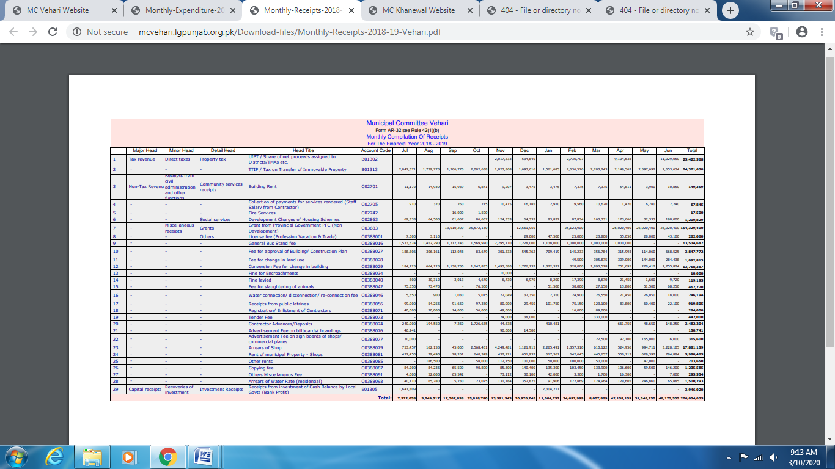

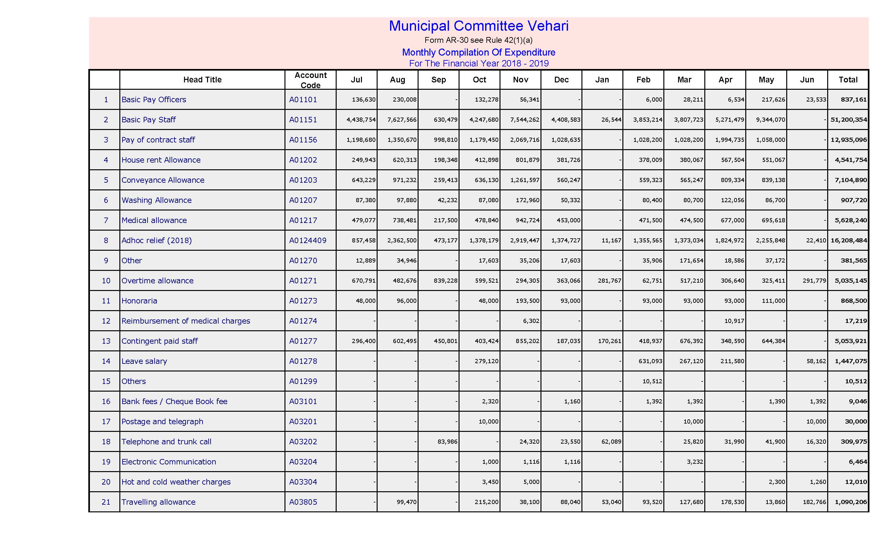

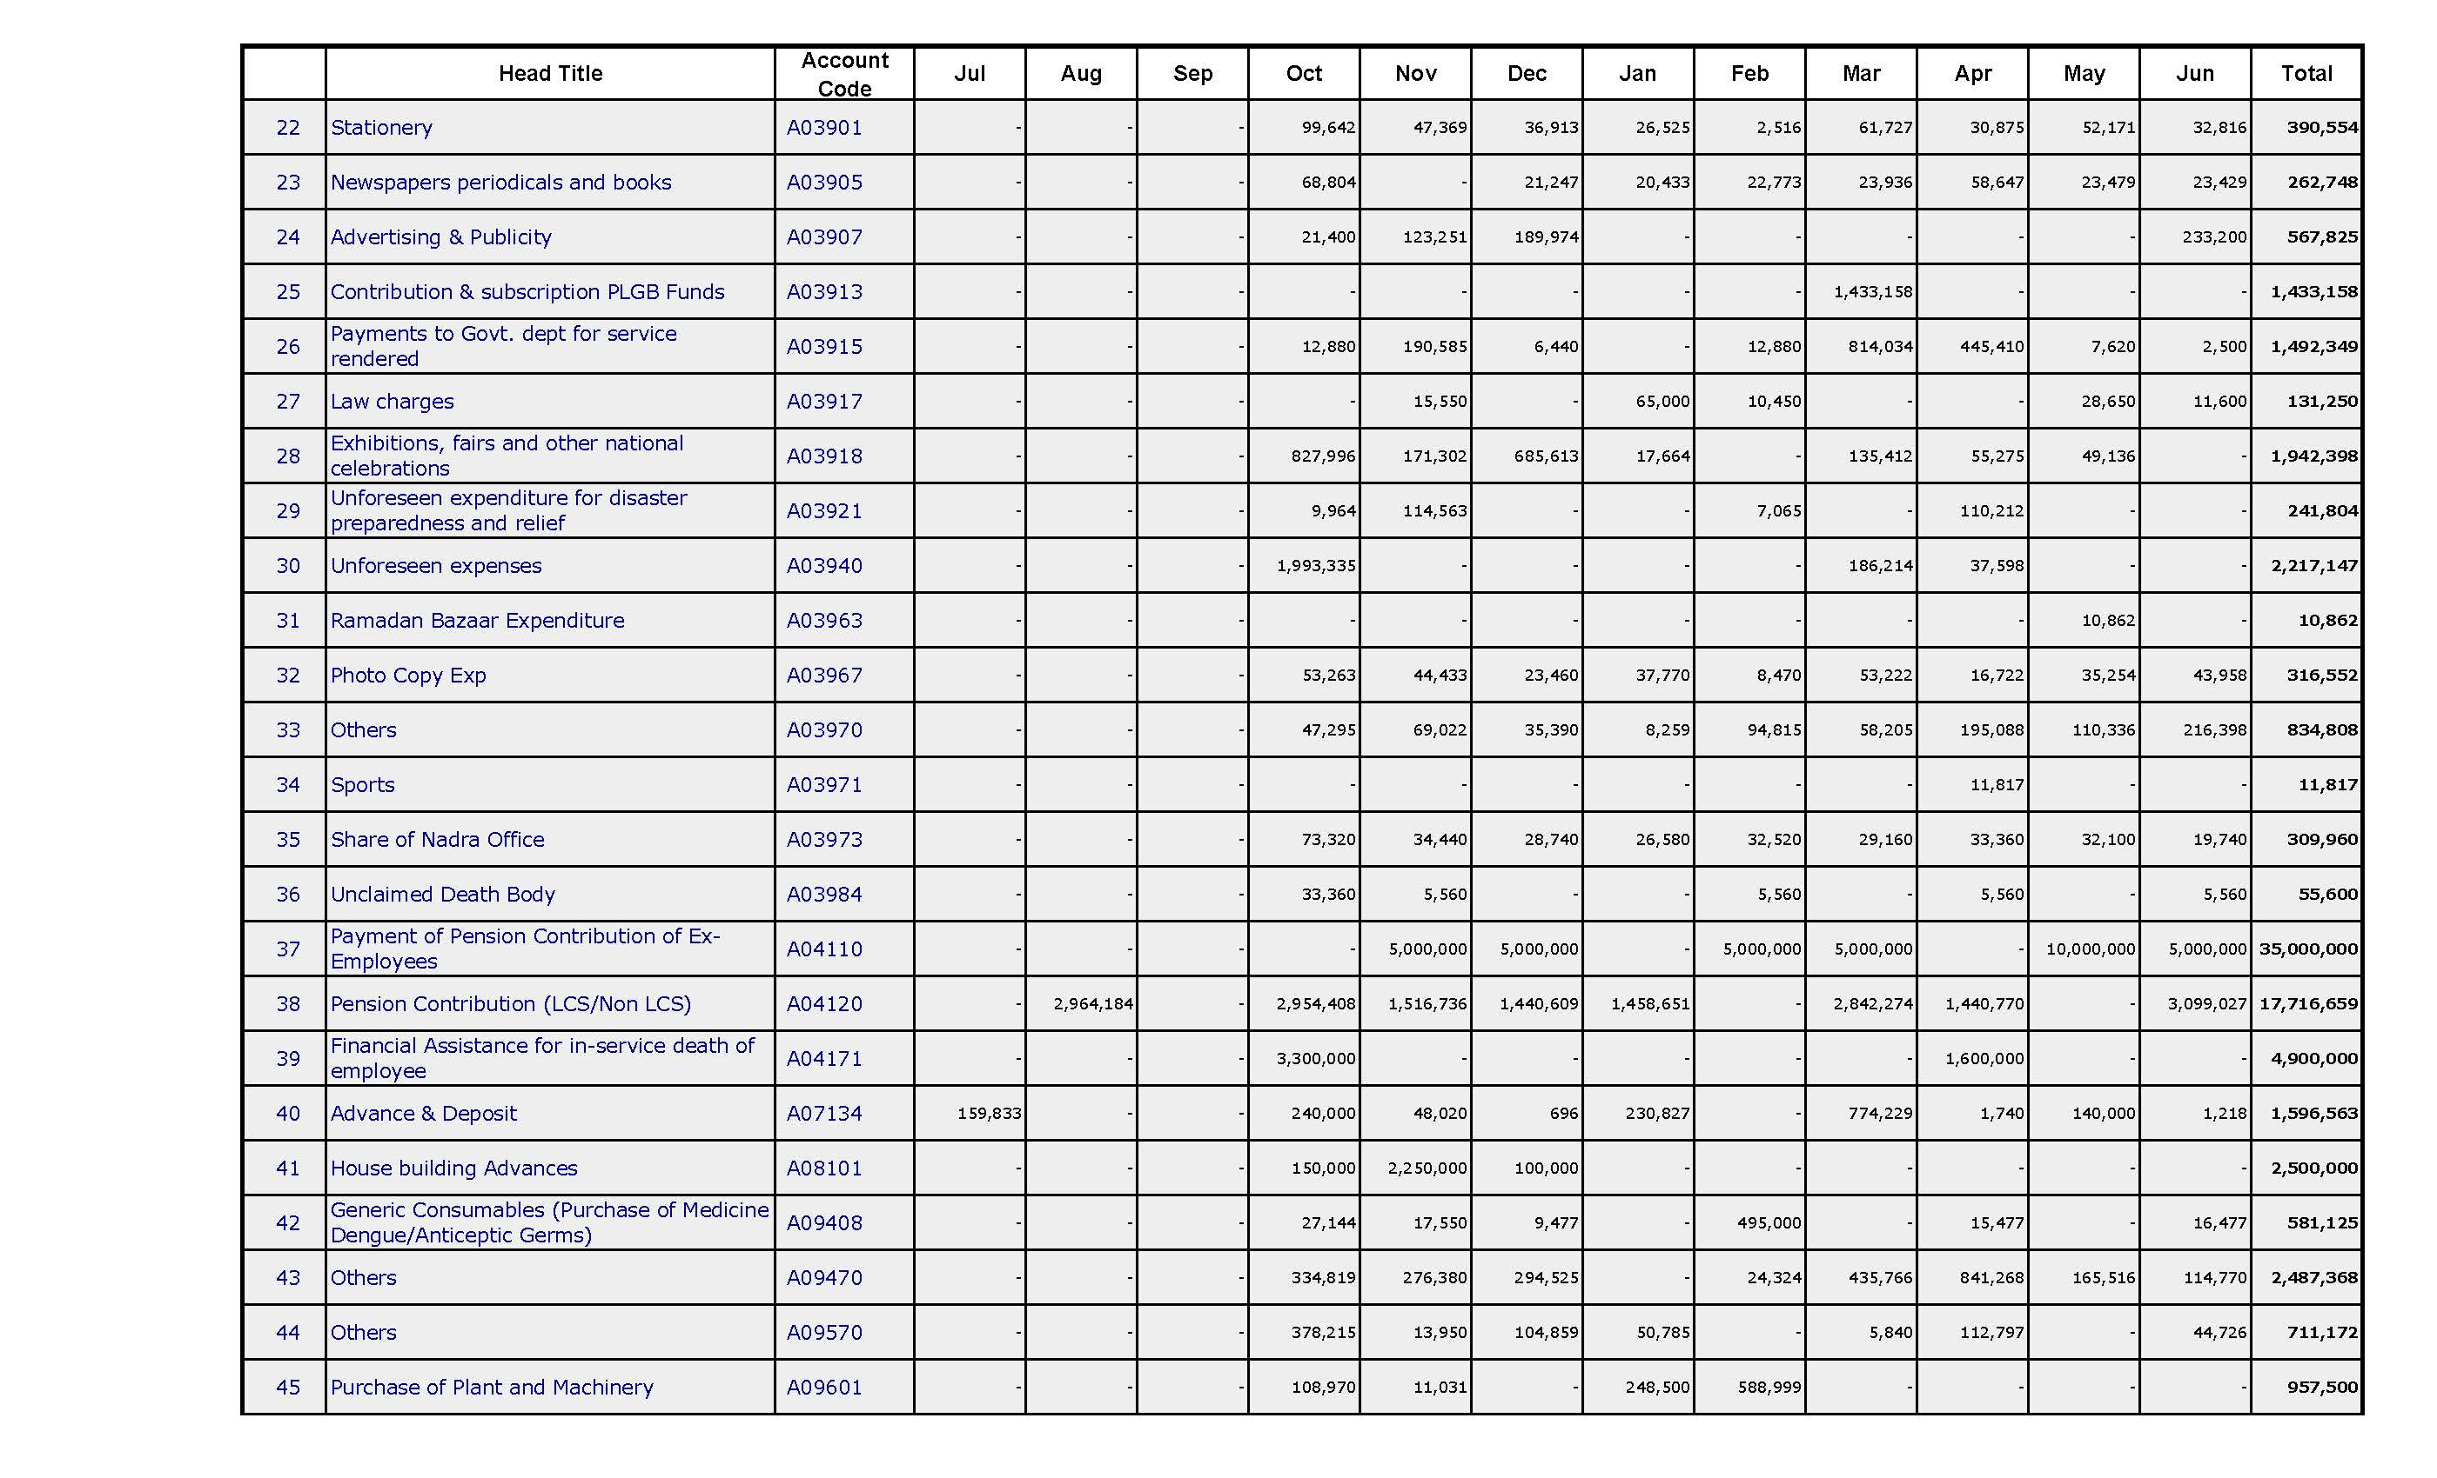

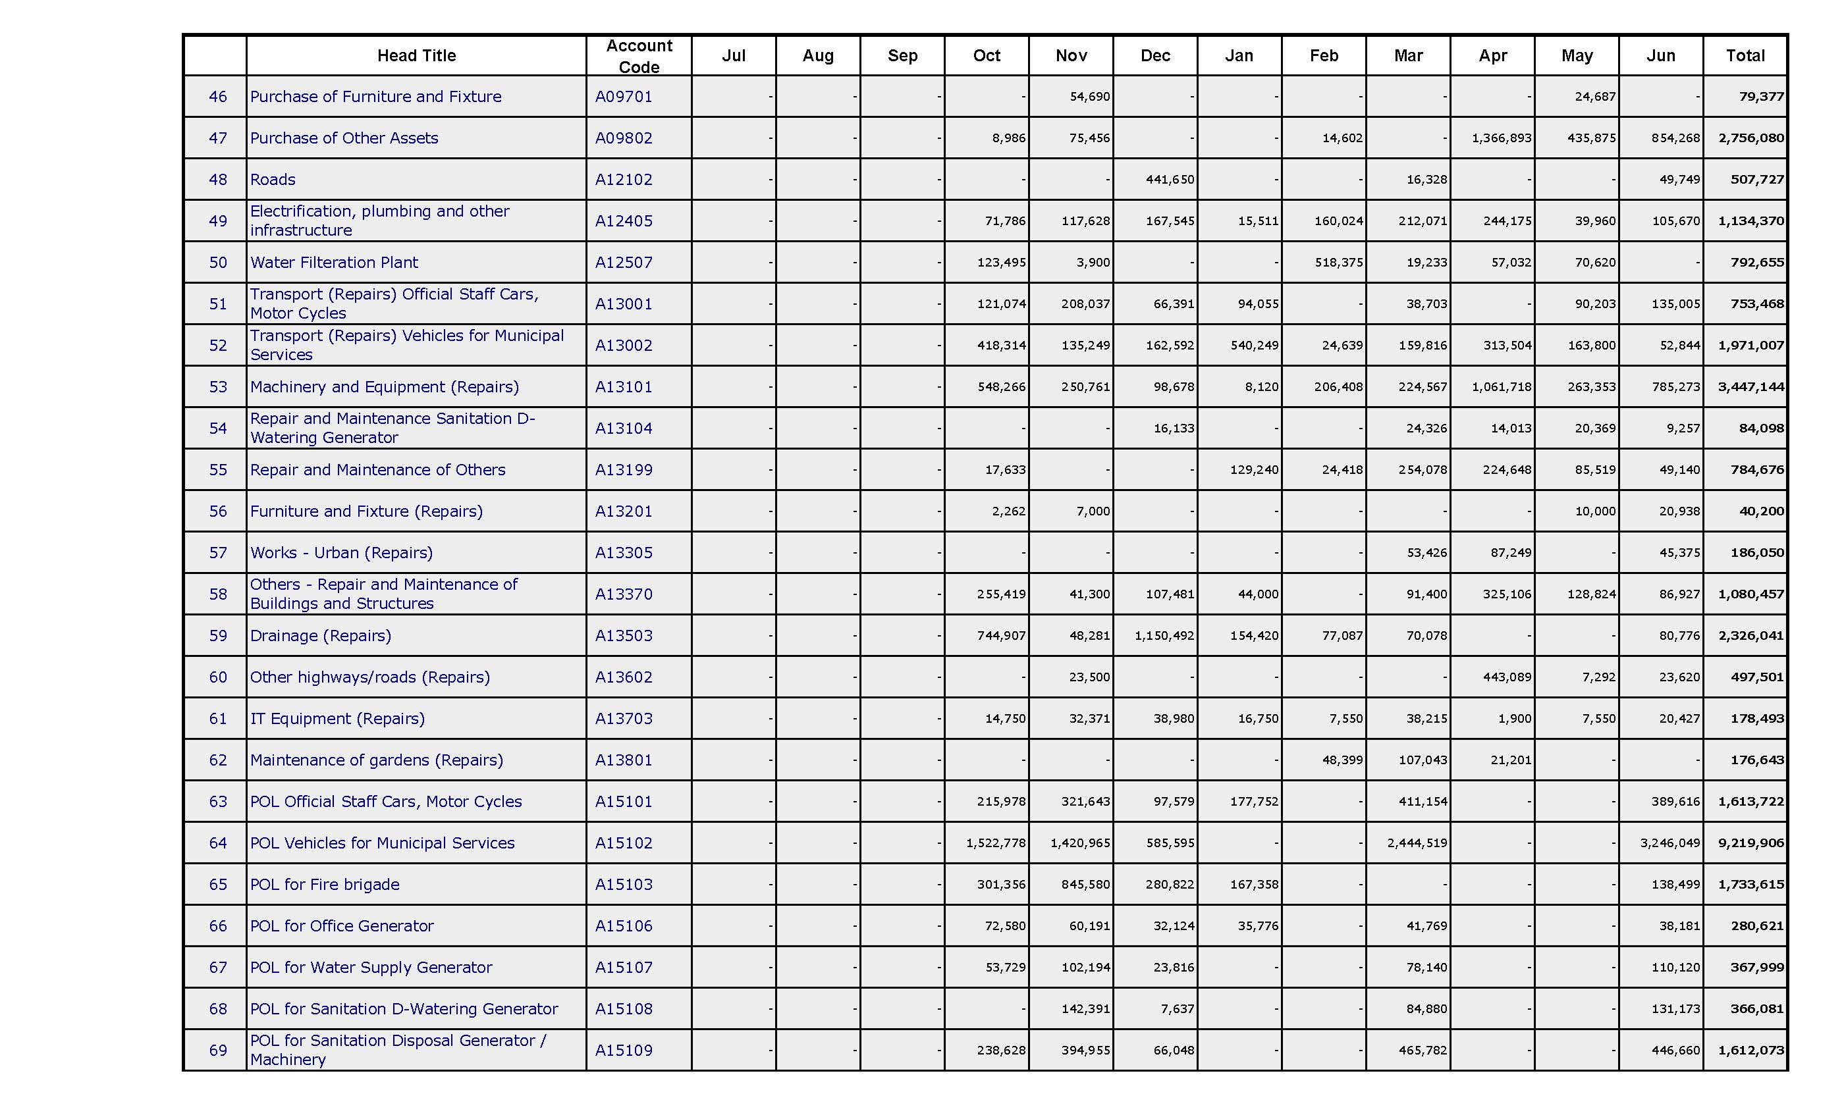

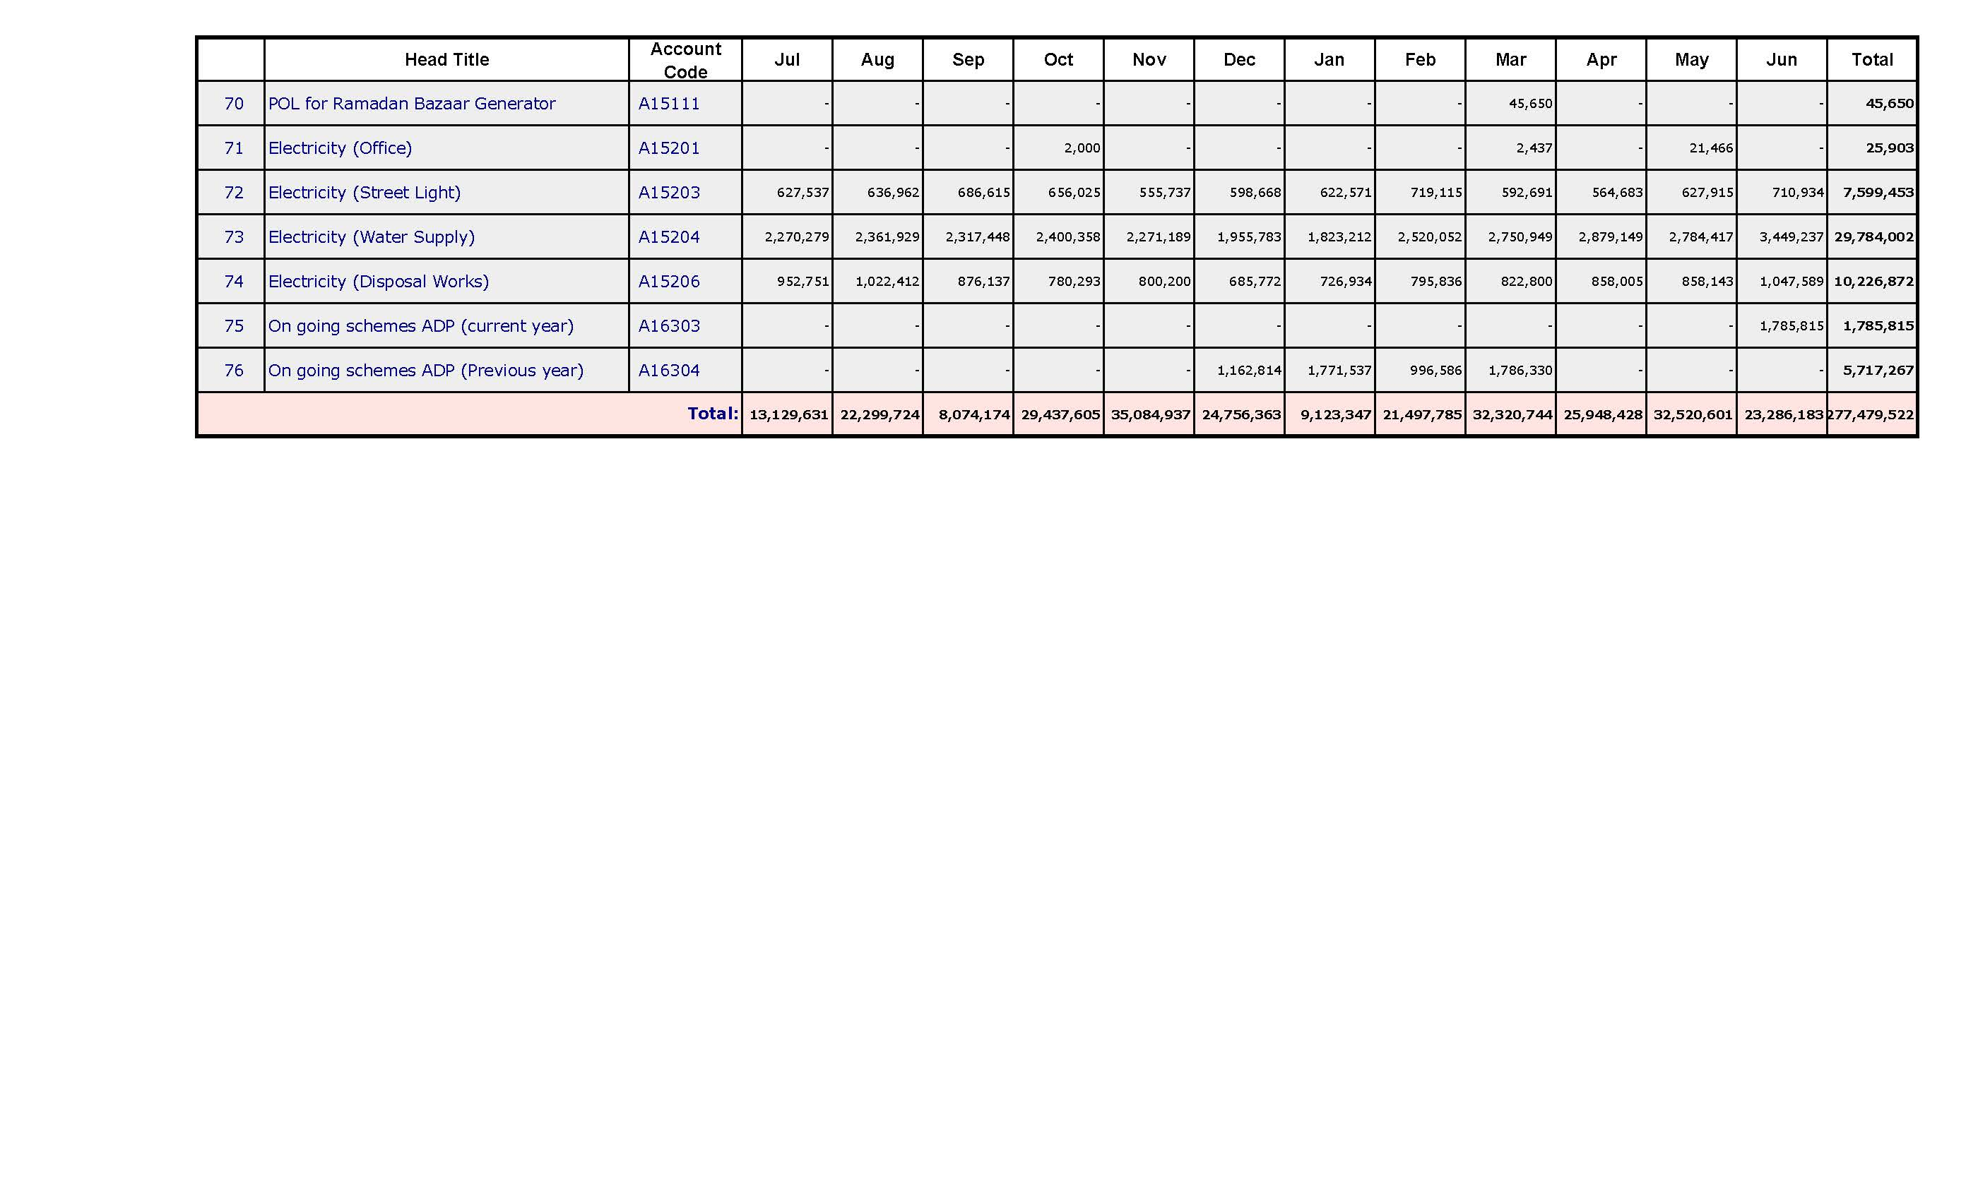

# Annex C

**MC Vehari - List of Approved Projects**

| **Sr. No** | **Name of Project** | **Gestation Period** | **Approved Cost  (PKR)** | **Status** | **Physical Progress  (%)** | **Remarks** |
| --- | --- | --- | --- | --- | --- | --- |
| **Year 2019-20** | | | | | | |
|  | Repair of Metalled Roads, Patch Work, Soling, Re-Soling, P.C.C, Tuff Tile Etc. for Muharram Routs City Vehari | 20-08-2019 to 07-09-2020 | 25,00,000 | Completed | 100% |  |
|  | Rehabilitation/improvement of metalled road from Govt. college for women to chungi No.05 chowk | 08-02-2020 to 30-05-2020 | 35,00,000 | Completed | 100% |  |
|  | Rehabilitation/improvement of metalled road from chungi No.05 chowk to eid Gah chowk and zoo road Vehari | 08-02-2020 to 31-05-2020 | 25,00,000 | Completed | 100% |  |
|  | Rehabilitation/improvement of metalled road from club road to imam bar Gah chowk Madina colony Vehari | 08-02-2020 to 28-05-2020 | 15,00,000 | Completed | 100% |  |
|  | Rehabilitation/improvement of metalled road from Hamdard Bakeri to Quaid-e-Azam Park Vehari | 08-02-2020 to 30-05-2020 | 18,00,000 | Completed | 100% |  |
|  | Rehabilitation/improvement of metalled road from club road to Nursing School road Vehari | 08-02-2020 to 30-05-2020 | 20,00,000 | Completed | 100% |  |
|  | Rehabilitation/improvement/ resurfacing of metalled road from Quaid -e- Azam chowk to masjid bhag wali club road (One way) and link roads | 20-03-2020 to 28-06-2020 | 20,00,000 | Completed | 100% |  |
|  | Rehabilitation/improvement of metalled road from Suzuki park to goal chowk Jinnah road and link roads | 15-02-2020 to 28-06-2020 | 20,00,000 | Completed | 100% |  |
|  | Rehabilitation/improvement of metalled road Behind Model school G block from Seed Form road to DHQ Hospital Road | 08-02-2020 to 28-05-2020 | 17,00,000 | Completed | 100% |  |
|  | Rehabilitation/improvement of metalled from Multan road to Disposal works Peer Murad and ward No.23 | 15-02-2020 to 28-05-2020 | 15,00,000 | Completed | 100% |  |
|  | Rehabilitation/improvement of metalled road from General Bus Stand to Main Chowk Danewal and link roads Danewal Vehari | 20-02-2020 to 28-05-2020 | 15,00,000 | Completed | 100% |  |
|  | Improvement of Green Belts and Plantation in medians and road side at DM Road, Ludden Road and Club Road, Vehari City". | 09-03-2020 to 09-05-2020 | 19,50,000 | Completed | 100% |  |
|  | Beautification, Installation Of Monuments Chowk Of City Vehari | 10-03-2020 to 22-04-2020 | 19,90,000 | Completed | 100% |  |
|  | Provision and placing of Benches at green belts along road side, Parks and chowks etc. city Vehari | 24-04-2020 to 28-04-2020 | 7,00,000 | Completed | 100% |  |
|  | Construction of precast wall around primary solid waste collection point mc Vehari | 07-04-2020 to 28-06-2020 | 6,00,000 | Work In Progress | 100% |  |
|  | Rehabilitation, Renovation and const. of Tower Khanewal Chowk and different structures in city Vehari. | 30-03-2020 to 28-06-2020 | 27,33,000 | Completed | 100% |  |
|  | Rehabilitation of metalled road/soling, re-soling, Sewerage Cold Store wali street, Green Town and Tariq Bin Zaid Colony Vehari | 28-05-2020 to 20-06-2020 | 20,00,000 | Completed | 100% |  |
|  | Rehabilitation of Sewerage, Soling, re-soling Peer Murad | 28-05-2020 to 20-06-2020 | 10,00,000 | Completed | 100% |  |
|  | Rehabilitation of metalled road darbar wali street Adjacent park south Katchi mandi/ Liaqat pura | 28-05-2020 to 25-06-2020 | 15,00,000 | Completed | 100% |  |
|  | Rehabilitation of metalled road, Soling and laying of Tuff Tile Iqbal Road Vehari | 28-05-2020 to 28-06-2020 | 10,00,000 | Completed | 100% |  |
|  | Rehabilitation of sewerage Muhallaha Anwarabad | 28-05-2020 to 20-06-2020 | 7,00,000 | Completed | 100% |  |
|  | Rehabilitation of metalled road, sewerage 9-11/WB Makkah Town | 28-05-2020 to 20-06-2020 | 10,00,000 | Completed | 100% |  |
|  | Rehabilitation of metalled road, Sewerage 9-11/WB Hafiz Tariq Wali Street | 28-05-2020 to 25-06-2020 | 10,00,000 | Completed | 100% |  |
|  | Rehabilitation of metalled road and sewerage U Block and V Block Peoples Colony Vehari | 28-05-2020 to 25-06-2020 | 10,00,000 | Completed | 100% |  |
|  | Rehabilitation of metalled road, sewerage etc. Chowk Rao Zulfiqar Wali street, Hafiz Amir wali street 9-11/WB and Rana Mango wali street | 28-05-2020 to 28-06-2020 | 15,00,000 | Completed | 100% |  |
|  | Rehabilitation of Metalled Road Street Malik Abdul Rehman wali Z-Block and replacement of Sewerage line Street Ch. Shahzaib Wali X Block Vehari | 28-05-2020 to 20-06-2020 | 8,00,000 | Completed | 100% |  |
|  | Rehabilitation of Metalled Road/Soling Street Ch. Zahid Karim Wali Lalazar Colony Vehari | 28-05-2020 to 20-06-2020 | 10,00,000 | Completed | 100% |  |
|  | Rehabilitation of Soling, Sewerage Mukhtar wali street Iqbal Town Near Tabligi Markaz | 28-05-2020 to 20-06-2020 | 5,00,000 | Completed | 100% |  |
|  | Purchase of. Container for Solid waste | 28-05-2020 to | 26,33,000 | Work In Progress | 50% |  |
|  | Purchase of Hydraulic Loader Rikshaw For Sanitation Branch | - | 30,00,000 | Work In Progress | re-tender Called and tender process is in progress | |
|  | Provision of street light with poles Masjid bagh wali to Railway crossing Multan road Vehari. | 28-05-2020 to | 35,00,000 | Work In Progress | 40% |  |
|  | Rehabilitation of metalled road, sewerage, Soling,re-soling etc. Bhatta Ikram UL Haq Vehari | 28-05-2020 to | 20,00,000 | Work In Progress | 40% |  |
|  | Providing and fixing of iron Grill in Chowks to protect the Green Belts and Monuments of City Vehari | 28-05-2020 to 28-06-2020 | 28,00,000 | Completed | 100% |  |