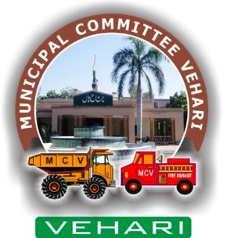

Annual Report

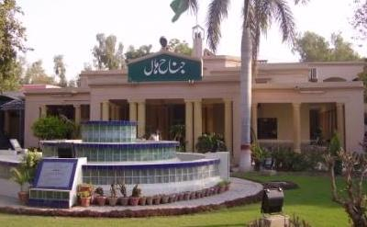

**Municipal Committee Vehari**

**2021-22**

*Vehari is one of the three Tehsils of district Vehari. It spreads over an area of 1,430 square kilometers with a population of 654,955*

*Tehsil Vehari borders with Bahawalnagar and Bahawalpur on the Southern side, with Pakpattan on the eastern, with Khanewal and Lodhran on western and with Sahiwal and Khanewal on northern side.*

Table of Contents

[1. Background: 1](#_Toc90648758)

[2. Map of City Vehari: 2](#_Toc90648759)

[3. Important Places 2](#_Toc90648760)

[4. Functions of Municipal Committee Vehari 3](#_Toc90648761)

[5. Human Resource at MC: 4](#_Toc90648762)

[5.1. Municipal Committee Organogram 4](#_Toc90648763)

[5.2. Administrative Setup 4](#_Toc90648764)

[5.3. Human resource Available at MC 6](#_Toc90648765)

[6. Covid – 19 (Response & Resilience) 6](#_Toc90648766)

[7. Anti-Dengue Activities 7](#_Toc90648767)

[8. Khidmat Apki Dehleez Per 8](#_Toc90648768)

[9. Trainings & Hands-on Sessions 9](#_Toc90648769)

[10. Annual Budget: 11](#_Toc90648770)

[10.1. Expenditures Incurred on Major Municipal Services 12](#_Toc90648771)

[11. Development Projects 12](#_Toc90648772)

[12. Municipal Services Delivery Detail 15](#_Toc90648773)

[12.1. Water supply system 15](#_Toc90648774)

[12.1.1. Water supply hours 15](#_Toc90648775)

[12.1.2. Total coverage of the city 15](#_Toc90648776)

[12.1.3. Tariff Structure 16](#_Toc90648777)

[12.1.4. Water filtration plants: 16](#_Toc90648778)

[12.1.5. The water quality & causes of shortage of water 16](#_Toc90648779)

[12.1.6. Man power deployment 17](#_Toc90648780)

[12.2. Solid Waste Management 17](#_Toc90648781)

[12.2.1. Solid waste Generation & Disposal 17](#_Toc90648782)

[12.2.2. Equipment & Machinery 18](#_Toc90648783)

[12.2.3. Manpower Deployed 18](#_Toc90648784)

[12.2.4. Coverage Detail 19](#_Toc90648785)

[12.2.5. Landfill development 20](#_Toc90648786)

[12.2.6. Vehicle parking Area: 20](#_Toc90648787)

[12.2.7. Levying of sanitation fees 20](#_Toc90648788)

[12.3. Sewerage 20](#_Toc90648789)

[12.3.1. Coverage 20](#_Toc90648790)

[12.3.2. Existing pumping / disposal stations 21](#_Toc90648791)

[12.3.3. Sucker & jetting machines 22](#_Toc90648792)

[12.3.4. Man power deployed 22](#_Toc90648793)

[12.3.5. Tariff structure 22](#_Toc90648794)

[12.3.6. Drainage zones 22](#_Toc90648795)

[12.3.7. Sewer lengths 24](#_Toc90648796)

[12.4. Streetlight 24](#_Toc90648797)

[12.4.1. Streetlights on Major roads: 24](#_Toc90648798)

[12.4.2. Ward wise detail of existing streetlights 24](#_Toc90648799)

[13. Complaint Management 25](#_Toc90648800)

[14. MC Website 26](#_Toc90648801)

[15. MC Response to the Requests of Citizens under RTI Act 2013 26](#_Toc90648802)

[Annex A 28](#_Toc90648803)

[Annex C 31](#_Toc90648804)

**Foreword:**

On behalf of the Municipal Committee Vehari, I hereby present this Annual Report for the financial year 2021-22. The report will give our stakeholders and communities an insight into the performance and achievements of the Municipal Committee. The current Annual Report outlines MCs successes and shortcomings in relation to our mandate as provided in the key focus areas of Local Governments. These can be summarized as; Building a Municipal Corporation that is efficient, effective and responsive; Strengthen Accountability and promote fairness in its dealings; Accelerating Service Delivery and supporting the vulnerable; Promoting Economic and Social development; Fostering Development Partnerships, Social Cohesion and Community Uplift Programs. It is pertinent to note that these endeavors’ can never be successfully achieved on their own but it becomes materialized by the collective efforts of officers, officials and support staff who work together in identifying challenges and to meet those challenges with rigor efforts and earnest professional approach.

It is commendable to note the improvements in relation to our spending and expenditure patterns, but we need to do more. The ever present excuse of lack of resource might be a legitimate one, but the key question is how effectively we use the resources at our disposal to accomplish our goals and attaining set targets. It is clear in this annual report that we are moving in the right direction. It is of paramount importance to synchronize our program plans with quarterly targets to achieve our broader goals effectively and efficiently.

**Administrator**

**Municipal Committee**

**Vehari**

# **Background:**

The city of Vehari is the administrative headquarters of [Vehari](https://en.wikipedia.org/wiki/Burewala_Tehsil) District. The district was created on 1st July 1976 comprising of the three former tehsils of [Multan District](https://en.wikipedia.org/wiki/Multan_District) ([Vehari](https://en.wikipedia.org/wiki/Vehari), [Burewala](https://en.wikipedia.org/wiki/Burewala) and [Mailsi](https://en.wikipedia.org/wiki/Mailsi)). The name Vehari means low-lying settlement by a flood water channel. The district lies along the right bank of the River [Sutlej](https://en.wikipedia.org/wiki/Sutlej), which forms its southern boundary. Vehari is known to be a city of [cotton](https://en.wikipedia.org/wiki/Cotton), among other crops and has dozens of cotton processing factories &[cottonseed oil](https://en.wikipedia.org/wiki/Cottonseed_oil) manufacturing plants along with [sugarcane](https://en.wikipedia.org/wiki/Sugarcane) farming and processing. Fruits grown over here include [mangoes](https://en.wikipedia.org/wiki/Mango) in the summer and [guava](https://en.wikipedia.org/wiki/Guava) and other citrus fruits in the winter.

Vehari city is located at 100 km (62 miles) distance from the historical city of [Multan](https://en.wikipedia.org/wiki/Multan) in the east at old Multan-Delhi Road constructed by Indian Muslim Emperor [Sher Shah Soori](https://en.wikipedia.org/wiki/Sher_Shah_Suri" \o "Sher Shah Suri) and is the headquarters of [Vehari District](https://en.wikipedia.org/wiki/Vehari_District). It is located at 300 02’ N and 720 21’E and connected with all cities through rail and road

The climate in Vehari is called a desert climate. July & August are hottest months when the temperatures generally reaches to 45°C and in night the average minimum temperature drops down to 28°C. The average humidity of city in August is 72%

Winter season starts from November and lasts till February. Mean maximum and minimum temperatures recorded during the month of January are about 21 and 5 degree Celsius respectively.

As per provisional statistics of Population census 2017, the population of Vehari city has been observed to be 112,840 persons in 2018. However the city had a population of 170,330 persons as per Land Scan exercise run in 2015 and projected up to 2017 at an annual growth rate of 3.36%. The population will rise to 237,037 persons in the year 2027 with this growth rate. It means that some inhabited areas of the city have not been included in the municipal limits which need to be extended by taking all the populated areas in the city limits.

**Economic Activities in the City**

Vehari is a rich agricultural land. The major profession of the people of **Vehari** is agriculture. The major crops are Wheat, Groundnut, Maize and all kinds of vegetables. However, almost 10- 20 % people are job workers or running their own businesses. The Vehari has following major industry;

* Handicrafts
* Chemical Industry
* Ginning Mills
* Agro Based Industry
* Shoe Industry
* Pesticides
* Pharmaceuticals
* Packaging Industry
* Storage Industry
* Paper Industry
* Flour Mills
* Plastic Products
* Textile
* Cold Storage
* Warehouse

# **Map of City Vehari**:

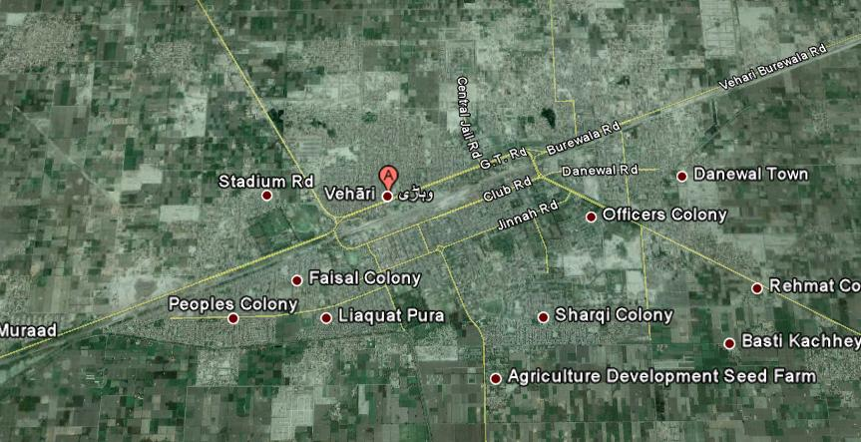

# Important Places

|  |  |
| --- | --- |
| http://mcvehari.lgpunjab.org.pk/larg-images/Import-place/main-gate-vehari.jpg | D:\mcvehariweb\larg-images\Quaid-e-Azam.jpg |
| **Welcome Vehari Entrance** | **Quaid-e-Azam Chowk** |
| D:\mcvehariweb\larg-images\monment\130496380_2756439997953171_5704666199495250947_n.jpg | http://mcvehari.lgpunjab.org.pk/larg-images/V-Chowk-Vehari.jpeg |
| **Monuments at Quaid-e-Azam Chowk** | **V Chowk Vehari** |
| D:\mcvehariweb\larg-images\Import-place\WhatsApp Image 2020-06-30 at 2.54.03 PM.jpeg | D:\mcvehariweb\larg-images\Import-place\WhatsApp Image 2020-06-30 at 2.53.52 PM.jpeg |
| D:\mcvehariweb\larg-images\Import-place\WhatsApp Image 2020-06-30 at 2.53.52 PM.jpeg | D:\mcvehariweb\larg-images\Import-place\WhatsApp Image 2020-06-30 at 2.54.24 PM.jpeg |

# **Functions of Municipal Committee Vehari**

Municipal Committee Vehari is responsible for performing the following functions as per new PLGA 2019:

1. Economic and value chain development;
2. Management of primary, elementary and secondary education facilities;
3. School enrolment and universal education;
4. Monitoring and supervision of primary health care facilities;
5. Preventive health and hygiene;
6. Population welfare including population control;
7. Solid waste collection and disposal;
8. Sewerage collection and disposal including water management and treatment;
9. Building control and land use;
10. Births, deaths, marriages and divorce registration;
11. Museums and art galleries;
12. Open markets;
13. Livestock and agriculture markets;
14. Public parking facilities;
15. City roads and traffic management & Public transport;
16. Abstraction of water for industrial and commercial purposes;
17. Emergency planning and relief;
18. Support to provincial agencies in prevention of crime and maintenance of public order; and
19. Regulatory enforcement in the functions
20. Establishment and management of pre-schools & Libraries;
21. Drinking water supply;
22. Burials, cremations etc.;
23. Public conveniences;
24. Children's services & Community safety;
25. Arts and recreation &Public fairs and ceremonies & Sports
26. Environmental health, awareness and services;
27. Parks and landscape development;
28. Slaughtering of animals;
29. Street lights; and Sign boards and street advertisements.

# Human Resource at MC:

## Municipal Committee Organogram

## Administrative Setup

|  |  |
| --- | --- |
| **ADC(R)/Administrator**  Syed Khalid Mahmood Gillani  *Date of Joining: 17-06-2022*  067-3361308 |  |
| D:\mcvehariweb\images\MC-office\co-ali-ahmed-sabir.jpeg**Chief Officer**  Ali Ahmed Sabir  Date of Joining: 24-08-2022  Ph. No.0304-6284445 |  |
| **Municipal Officer (Regulation)**  Vacant  Date of Joining:  Ph. No. |  |
| **Municipal Officer (Finance)**  Amjad Hussain (Additional Charge)  Date of Joining: 27-10-2021  Ph. No. 0301-7666911 | D:\mcvehariweb\images\MC-office\amjad-hussain-mof.jpeg |
| **Municipal Officer (Infrastructure & Services)**  Badar Majeed  Date of Joining: 23-09-2022  Ph. No.0300-9636323 | D:\mcvehariweb\images\MC-office\badar-majeed-MOIS.jpeg |
| **Municipal Officer (Planning)**  Ijaz Iqbal  Date of Joining: 30-07-2022  Ph. No. 0300-7696456 | D:\mcvehariweb\images\MC-office\MOP.jpeg |

## Human resource Available at MC

|  |  |  |  |
| --- | --- | --- | --- |
| Vacancy Analysis-Section Wise | | | |
| Section | **Sanctioned** | **Filled** | **Vacant** |
| Chairman/ Vice Chairman | 5 | 2 | 3 |
| Chief Officer | 17 | 14 | 3 |
| Municipal Officer (F) | 18 | 16 | 2 |
| Municipal Officer (R) | 17 | 13 | 4 |
| Municipal Officer (P) | 10 | 5 | 5 |
| Municipal Officer (I) | 45 | 18 | 27 |
| Municipal Officer (S) | 355 | 279 | 76 |
| Total | **467** | **347** | **120** |

MC schedule of establishment is attached as Annex – A

# Covid – 19 (Response & Resilience)

As early as late 2019, MC management was aware of and beginning to prepare for COVID-19. Administratively, the management began preparing of pandemic plans and connected with other community stakeholders. This helped the city be prepared when it started seeing cases in Vehari. As the COVID-19 situation continued to evolve, the city of Vehari took precautionary measures to protect both staff and the community against the spread of Coronavirus. In response to the increasing levels of response required to follow the recommendations of health professionals. The city of Vehari activated and mobilized its emergency team to curb the pandemic and to avoid as many people from the grip of this disease. By taking emergency measures, the city was able to nimbly respond to the constantly changing environment that COVID-19 presented.

Throughout the pandemic, the city has had three main goals:

* To implement the Standards Operating Procedures (SOPs), protocols and decisions taken by the National Command and Operation Centre (NCOC), Government of Pakistan
* To protect the health and safety of staff throughout the duration of the Pandemic;
* To protect the health and safety of the residents by taking precautionary measures;
* To ensure the provision of critical services to the residents, health care facilities, and businesses.
* To create awareness campaigns and messages to sensitize people, residents and other stakeholders time to time.

City Administration hosted weekly group meetings with the hospital, Augustana, senior’s care providers, and school board officials in order to pool information and share what the municipality was doing. Keeping the public updated through social media, print media and motivational materials was a top priority.

# Anti-Dengue Activities

Dengue is a social problem and can be overcome only by including all segments of the society in the anti-dengue drive. By considering need of the hour, MC took steps to create awareness among the people to keep their houses clean and remove stagnant water. MC had been implemented anti-dengue regulations and stern action were imposed on their violators. MC management had given top priority to overcome dengue and special teams had been constituted to keep surveilling high risk areas. In this regard, daily surveillance schedules were prepared, micro plans were developed, field teams were mobilized and social segment of the society were activated to curb the wide spread of epidemic.

|  |  |
| --- | --- |
|  |  |
|  |  |
|  |  |

# Khidmat Apki Dehleez Per

On the directions of [Chief Minister Punjab](https://www.urdupoint.com/en/latest-news/chief-minister-punjab.html), [Sardar Usman Buzdar](https://www.urdupoint.com/en/latest-news/usman-buzdar.html" \t "_blank), 'Khidmat Apki Dehleez per' program was launched in the Vehari City. The basic purpose of the program was to revive government machinery for effective delivery of services. Municipal Committee Vehari were also given specific tasks in accordance with the needs of the public to ensure the effectiveness of service delivery mechanisms. The program was truly beneficial for the masses. Weekly [schedule](https://www.urdupoint.com/business/prize-bonds-draw-schedule.html) was issued in which the officers of municipal committee monitored the sanitation, sewerage and other matters in their allocated areas. The citizens were asked to identify/ highlight the areas that needs quick attention from Government departments, and Government officials will respond to their issues/suggestions. The activities under “Khidmat Apki Dehleez Par” program had been intensified to clean and beautify government buildings as well as parks, intersections and green belts in all areas of the city. Horticultural development was of great importance and for the purpose, MC Vehari along with other departments in had taken special measures to beautify the City. The Administrator monitored the activities being conducted under the program Apki Dehleez Par to ensure that there was no delay in the resolution of people’s problems and all targets were achieved well in time.

|  |  |
| --- | --- |
|  |  |
|  |  |
|  |  |

# Trainings & Hands-on Sessions

LG&CD Department with the technical assistance of Punjab Municipal Development Fund Company (PMDFC) often organized training programs and hand on sessions for MC management and staff on need basis. PMDFC team always provides continuous support to MCs’ staff for MCs institutional strengthening and capacity building and to enhance performances. Various institutional interventions such as GIS maps, Computerized Financial Management System, Performance Management System, Computerized Complaint Tracking System and MCs’ websites has been developed, implemented and make functional in MC. However, MC management and staff are putting its best efforts for accomplishing the heightened scope of work against these interventions to obtain the subsequent Performance Based Grants (PBGs) against related Performance Measures (PMs) under PCP. In this context, to fulfill the MACs and PMs under PCP, the detail of work has been chalked out and mentioned below:

|  |  |  |
| --- | --- | --- |
| Sr. No. | Interventions | Detail of Work |
| 1 | GIS Maps | Updated GIS based maps are available with MCs   * Base maps, * Municipal Infrastructure maps (water supply, sewerage, solid waste, Road hierarchy & streetlight) |
| 2 | Computerized Financial Management System (CFMS) | * Budget Entry for the current financial year * Cash book entry for the current financial year * Receipts * Expenditures |
| 3 | Performance Management System (PMS) | * Reports on Performance Indicators to track status of municipal services i.e. water supply, sanitation and streetlights: * Expenditures details on various municipal services i.e. water supply, solid waste, street lights as per information provided by MCs * Customized reporting as per requirement |
| 4 | Computerized Complaint Tracking System (CCTS) | * Registration of complaints in the web based software * Sector wise (Water Supply, Solid Waste, Street Light, Sewerage System etc.) reports * Different analyses of resolved & unresolved complaints * Information pertaining complaint registration and resolution time |
| 5 | MC Websites | Update the links on MC website on regular/ need basis   * News & Event * Notice & Tenders * Administrative setup (Name of officer, date of joining, qualification, total service, contact No) * Budget * Incumbency * Other website links |

|  |
| --- |
| Actions accomplished for implementation of the interventions |
| A. MCs designated the officials to manage the interventions B. Refresher Trainings. C. Continuous follow-up by PMDFC D. MCs managed requisite hardware  E. MC management were sensitized to review systems generated reports on regular basis. |

|  |  |
| --- | --- |
| C:\Users\Naveed\Desktop\PMDFC Visit\WhatsApp Unknown 2021-10-06 at 2.45.29 PM\WhatsApp Image 2021-10-06 at 2.28.56 PM.jpeg | C:\Users\Naveed\Desktop\PMDFC Visit\WhatsApp Unknown 2021-10-06 at 2.45.29 PM\2.jpeg |
| C:\Users\Naveed\Desktop\PMDFC Visit\WhatsApp Unknown 2021-10-06 at 2.45.29 PM\5.jpeg | E:\PMDFC_Picture_Gallery\PCP\Workshop\2021\ESMF&PPRA-Session-PIMS-27-01-2021\27th Jan, 2021\IMG_2997.JPG |
| C:\Users\Naveed\Desktop\PMDFC Visit\WhatsApp Unknown 2021-10-06 at 2.45.29 PM\3.jpeg | C:\Users\Naveed\Desktop\PMDFC Visit\WhatsApp Unknown 2021-10-06 at 2.45.29 PM\WhatsApp Image 2021-10-06 at 2.28.58 PM (1).jpeg |

# **Annual Budget:**

## Expenditures Incurred on Major Municipal Services

1. Development Projects

**Infrastructure Projects Being Carried Out in Current FY under Punjab Cities Program**

|  |  |  |  |  |
| --- | --- | --- | --- | --- |
| Sr.# | Project Name | Project Detail | Duration  (Months) | Project Cost (Million Rs.) |
| 1 | **Rehabilitation of Municipal Services in MC Vehari (Group-A)** | * Water Supply * Installation of tube well * Vertical turbine Pump & Specials * Bulk Water Meter * External Electrification * Pump house * Rehabilitation of GST at IPS(Madina colony & 9/11 WB) * Rehabilitation of Pump house (plaster, painting etc.) at IPS * Replacement of sluice valves at IPS * Rehabilitation of brick pavement of approach road to at IPS * Replacement of pumping units in IPS H Block WW =2 Nos and Madina Colony WW = 1Nos * Replacement of hypo chlorinators * Replacement of sub-standard consumer connection * Rehabilitation of boundary walls of water works * Replacement of damaged transmission main (8" and 10") * Upgradation of UF water filtration plants by addition of RO filtration plants 1000 ltr/hr including arsenic removal plants and repair of civil works * P/F RO System Filtration Plant 1000 LPH * Installation of Power factor improvement equipment at source tube wells * Sewerage * Replacement of sullage pumping units (4 cusec) including sluice valves non-return valve and damaged piping in 9/11 disposal works * Painting of pumping machinery * Replacement of pen stock at disposal works * Replacement of screen at disposal works * Rehabilitation of pump house at disposal works * Raising of manholes & repair of gulley grating chambers * Supply of manhole covers with base frames. * Repair of boundary wall * Installation of Power factor improvement equipment at disposal works * Streetlight * Replacement of luminaries by LED Lights 120 watts * Parks * Kalsoom Nawaz Park * Muhammadi Park * Family Park khanewal Road * Office Equipment * Compact fluorescent lamp (CFL)/tube light with LED bulb (18 watt) | 8 | 96.94 |
| 2 | **Rehabilitation of Municipal Services in MC Vehari (Group-B, Repair Works)** | * **General overhauling of Massy tractor MF-385 Reg.# 1316/VRJ (Front End Loader)** complete in all respect including Engine over hauling, replacement of diesel engine pump, self-start and generator and hydraulic pump & jacks and replacement of tyres * **General overhauling of Massy tractor MF-385 Reg.# 7517/VRJ (Front End Loader)** complete in all respect including Engine over hauling, replacement of diesel engine pump, self-start and generator and hydraulic pump & jacks * **General overhauling of Massy tractor MF-375 (Front blade tractor)** complete in all respect including Engine over hauling, replacement of diesel engine pump, self-start and generator and hydraulic pump & jacks * **General overhauling of Massy tractor MF-240 Reg# VRG-1003 (Used for trolley)** complete in all respect including Engine over hauling, replacement of diesel engine pump, self-start and generator * **General overhauling of Massy tractor MF-240 Reg# VR-1510 (Used for trolley)** complete in all respect including Engine over hauling, replacement of diesel engine pump, self-start and generator, Gear Box and batteries etc. * **General overhauling of Fiat tractor 480 Reg# VRJ-1216 (Used for trolley)** complete in all respect including Engine over hauling, replacement of diesel engine pump, self start and generator, Gear Box and batteries and replacement of tyres etc. * **General overhauling of Arm roll truck Reg.# 16/VRJ** complete in all respect including Engine over hauling, replacement of jack and hydraulic system, Break & clutch system and replacement of tyres, denting and painting complete in all respect etc. (Quotation attached) * **General overhauling of garbage collecting dumper Reg.# 7577/VRJ** including replacement of dumper body, hydraulic & jack system, shock proof system, fry wheel, generator, Denting and painting complete in all respect etc. (Quotation attached) * General repairing of garbage containers 5 meter cube with mild steel sheets including welding and painting complete in all respect * **General overhauling of Jetting machine** complete in all respect. * Replacement of Hydraulic pipe3/4" i/d imported(Germany) 200 Rft, tyres 6 Nos., pressure tank, head adopter, pressure pipe, pressure nozzle, clutch break, denting and painting complete in all respect * **General overhauling of Sucker machine** complete in all respect. * Replacement of waste water tank as per existing specification of sucker machine, suction pipe, pump side engine overhauling, suction pump, clutch break, denting and painting tyres 6 Nos., complete in all respect (Detail attached) * Provision of winch machines for de silting of collecting tanks of disposal works. * Provision of winch machines for de-silting and cleaning of sewer lines. * Providing and fixing of front and rare tyre made by general company with 6 ply AT design. Size 750-16 * Providing and fixing of rare tyre made by general company with 6 ply PL design. Size 12.4/11-28 * Providing and fixing of rare tyre made by general company with 8 ply SAGT design. Size 18.4/15-30 | 6 | 4.22 |

The detail of development projects other than PCP are given as Annex - B

# Municipal Services Delivery Detail

## Water supply system

### **Water supply hours**

On an average MC is supplying 02 hours of water to households daily as per given schedule

|  |  |  |  |  |
| --- | --- | --- | --- | --- |
| Water supplied hours | | | | |
| **Early Morning** | **Morning** | **Midday** | **Evening** | **Total** |
| **0.5** | **0.5** | **0.5** | **0.5** | **2.0** |

### Total coverage of the city

The total area coverage of water supply in the city is 57% out of which 6% area falls under water shortage and 13% under the water contamination. Rest of 43% area is un-served. The detail of water connections and percent connected are given as under;

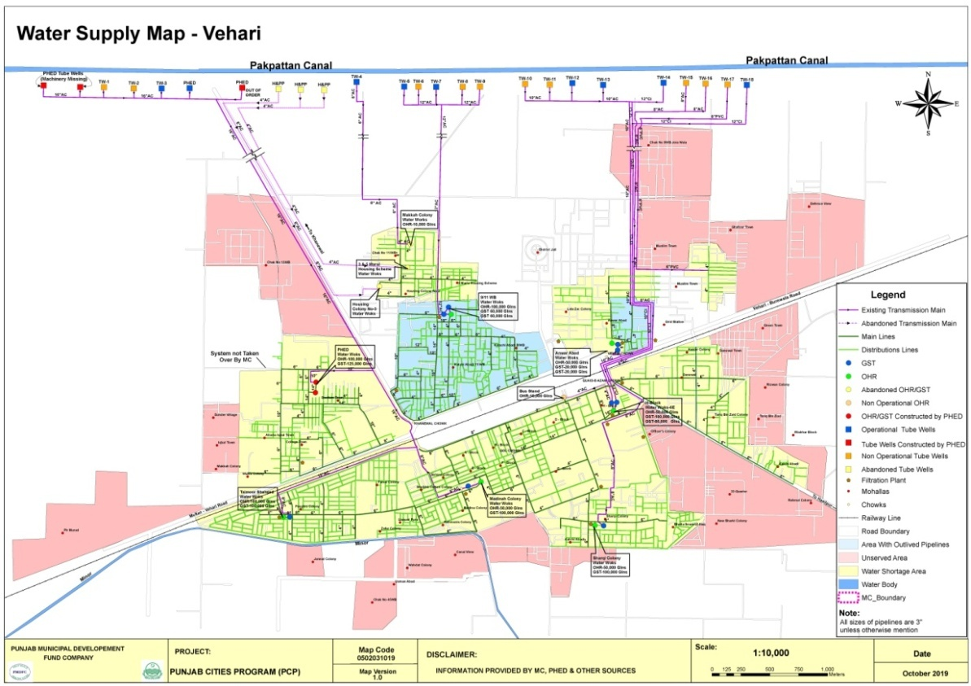

|  |  |  |  |  |
| --- | --- | --- | --- | --- |
| No. of connections | | | | %age connected |
| **Domestic** | **Commercial** | **Industrial** | **Total** |
| 6172 | 62 | 0 | 6234 | 10% |

The water supply hours are very short and the water shortage prevails at remote ends of the distribution system because of unequal distribution of water in the absence of consumer metering.

### Tariff Structure

The consumer’s connections are not metered and hence water. The water rates are given below;

|  |  |  |
| --- | --- | --- |
| Tariff Rates per month | | |
| **Domestic** | **Com.** | **Ind.** |
| Rs. 100 | Rs. 300 | 2000 |

### Water filtration plants:

Total 11 filtration plants are being maintained by MC in the city to supply potable water to the in habitants. All are working in good condition and no need for repair of its component to supply potable water to the in habitants of the city.

### The water quality & causes of shortage of water

Deep tube wells have been installed along the Pakpattan Canal which has been remodeled by reducing its discharge. As such very little seepage from the canal is intercepted by these tube wells and hence the quality of these tube wells has deteriorated. The tube wells are pumping into six intermediate pumping stations in the city and water has varying TDS value from 305 ppm to 1045 ppm.

The source at Pakpattan Canal cannot afford installation of additional tube wells and some other fresh water aquifer around the city will have to be tapped to supply fresh water to the city residents. To fight the water shortage on urgency basis replacement and repair of tube well is required.

Main and the only reason for water shortage is the scarcity of fresh water in and around the city. Sub soil water in the city is brackish and unfit for human consumption and hence water has to be imported in the city from some fresh water zone. Unless a comprehensive scheme for tapping the fresh water is planned and launched, the water shortage cannot be addressed

Lot of water wastage is occurring in the water supply system in below given ways;

1. Some consumer connections have no taps.
2. Some consumers keep the taps open in all water supply hours although they do not need water.
3. Most of the overhead tanks of the consumers have no float valve and when their tank is full, the water flows down to the drains continuously during the supply hours.

The water wastage requires excessive water production and high electricity consumption. It is exerting a large pressure on the municipal budget. Large savings in the electricity bills and ultimately the O&M cost, can be affected by reducing the water wastage at the consumer ends. It will save lot of water and water shortage can be addressed by conservation of water being wasted at present. The best and efficient way to save water and reduce O&M cost is the consumer metering.

### Man power deployment

|  |  |  |  |  |  |  |
| --- | --- | --- | --- | --- | --- | --- |
| Slot | Sanctioned strength | Existing strength | Vacant post | Manpower on daily wages | Total man power deployed | Additional  MC demand |
| Tube-well operators | 31 | 23 | 8 | 0 | 23 | 40 |
| Chowkidars | 3 | 2 | 1 | 0 | 2 | 10 |
| Electricians | 0 | 0 | 0 | 0 | 0 | 5 |
| Plumbers | 1 | 0 | 1 | 0 | 0 | 10 |
| Plumber helpers | 0 | 0 | 0 | 0 | 0 | 5 |
| Fitter Quli | 3 | 3 | 0 | 0 | 3 | 10 |
| Baildar | 6 | 5 | 1 | 0 | 5 | 10 |
| Water Superintendent | 1 | 1 | 0 | 0 | 1 | 1 |
| Total | 45 | 34 | 11 | 0 | 34 | 91 |

The vacant positions of the field staff need to be filled for satisfactory service delivery.

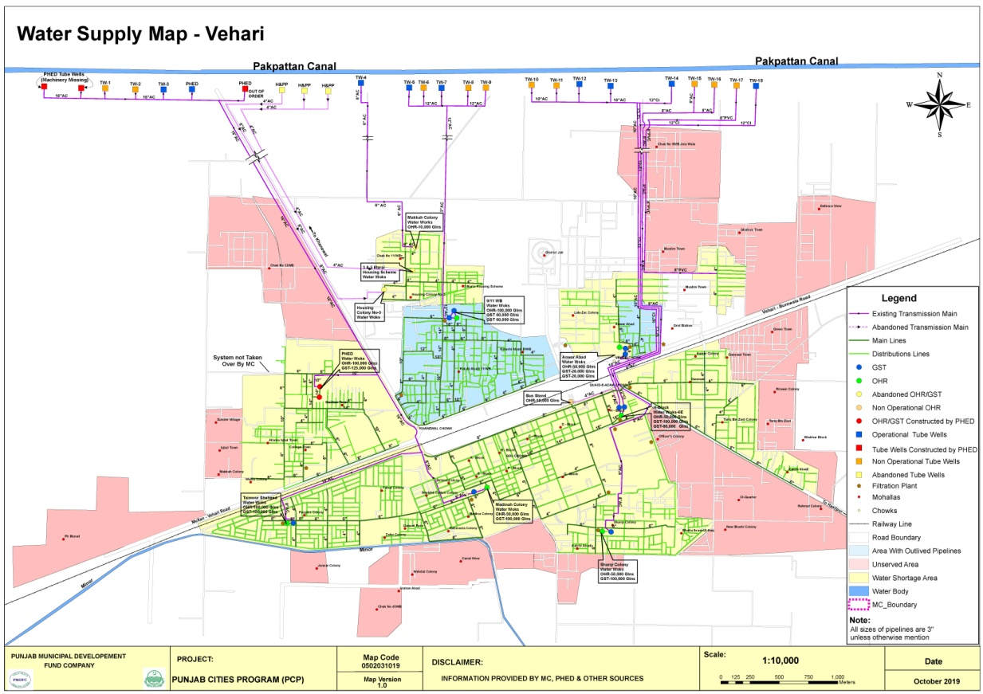

## Solid Waste Management

### Solid waste Generation & Disposal

The solid waste management efficiency along with present dumping sites is given below;

|  |  |
| --- | --- |
| Total waste generated | 76 Tons |
| Waste disposal | 48 Tons |
| % age efficiency | 62% |

### Equipment & Machinery

Under mentioned collection and transportation machinery is available with MC to handle the solid waste.

|  |  |  |  |  |
| --- | --- | --- | --- | --- |
| S.N | Equipment/machinery | Total available  Nos. | Working | Requiring repair (Nos) |
| 1 | Tractor trolleys | 3 | 3 | - |
| 2 | Arm roll truck | 1 | 1 | - |
| 3 | 5.0 m3 containers | 7 | 7 | - |
| 4 | Garbage dumpers | 5 | 5 | 2 |
| 5 | Front blade tractors | 2 | 2 |  |
| 6 | Front end loaders | 3 | 3 | - |
| 7 | Water bouzers | 2 | 2 | - |
| 9 | Mechanical sweepers | 1 | 1 | - |

The existing machinery is neither sufficient nor cost effective and efficient giving rise to low efficiency of collection and disposal of the waste and as a result of that MC is facing higher waste management cost as well as complaints regarding the insanitary conditions in the city. Efficient and cost effective machinery is needed to increase the efficiency of collection and transportation for improving the sanitary conditions and lowering down the operational and maintenance costs.

### Manpower Deployed

The manpower deployed for collection, transportation and disposal of the solid waste is given in the table below. As indicated by MC Officers, this manpower is not sufficient to serve the entire city at the given standards. Additional manpower required by the MC is also given here. Actual requirement will be identified after detail design and implementation of the project.

|  |  |  |  |  |  |  |
| --- | --- | --- | --- | --- | --- | --- |
| Slot | Sanctioned strength | Existing strength | Vacant posts | Manpower on daily wages | Total man power deployed | Additional  MC demand |
| Sanitary workers | 198 | 146 | 52 | 27 | 173 | 150 |
| Vehicle drivers | 18 | 3 | 15 | 0 | 3 | 5 |
| Supervisors | 7 | 2 | 5 | 0 | 2 | 10 |
| Sanitary inspectors | 0 | 0 | 0 | 0 | 0 | 5 |
| Clerk | 1 | 0 | 1 | 0 | 0 | 4 |
| Other | 0 | 0 | 0 | 0 | 0 | 0 |
| Total | 224 | 151 | 73 | 27 | 183 | 174 |

### Coverage Detail

The entire city is not served with solid waste collection and disposal. 35% area of the city is fully served, 40% is partially served and 25% is un-served as marked on the map. In partially served areas service is rendered intermittently depending upon availability of manpower and transportation machinery. The detail of these areas is given below.

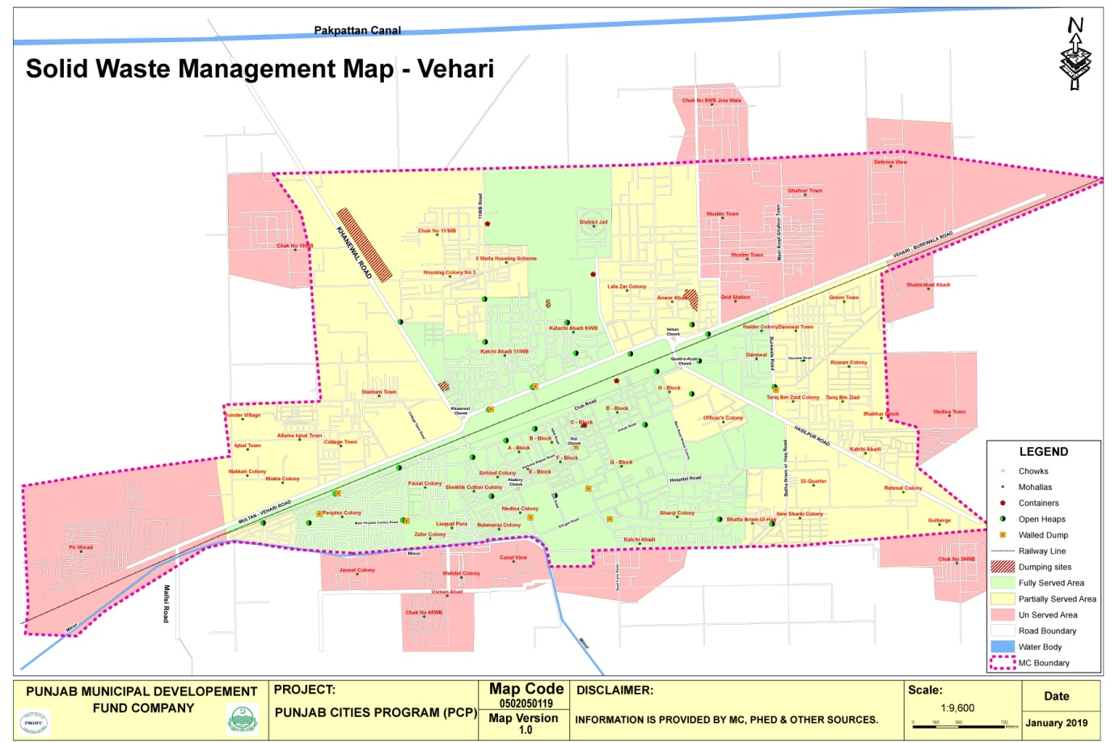

* Vehari City is divided into 10 Circles.
* 10 Supervisor are responsible to clean the city on daily basis.
* 40 collection points are cleaned on daily basis with help of 2 trucks.

Stray dogs are killed regularly to control Rabies

**a) Partially served areas**

No regular service is rendered in the under mentioned areas. The main complaints are attended by sending the machinery & labor once or twice a week.

|  |  |  |  |  |  |
| --- | --- | --- | --- | --- | --- |
| 1 | BhattaI kramul Haq | 2 | New Sharqi Colony | 3 | 32-Quarter |
| 4 | Rehmat Colony | 5 | Kachi Abadi | 6 | Iftikhar Block |
| 7 | Tariq Bin Zaid | 8 | Officers Colony | 9 | Danewal Town |
| 10 | Green Town | 11 | Anwar Abad | 12 | Lalazar Colony |
| 13 | 3-Marla Scheme | 14 | Housing Scheme No.3 | 15 | Chak No. 11/W.B |
| 16 | Stadium town | 17 | College Town | 18 | Allama Iqbal Town |
| 19 | Wukla Colony | 20 | Gulberg | 21 | Madina town |
| 22 | Makkah colony | 23 | Sunder village | 24 | Chak no 13 WB |

1. **Unserved areas**

Under mentioned areas are still un-served;

|  |  |  |  |  |  |
| --- | --- | --- | --- | --- | --- |
| 1 | Defence View Society | 2 | Ghafoor Town | 3 | Muslim Town |
| 4 | Grid station | 5 | PirMurad Colony | 6 | Chak No. 9/W.B |
| 7 | Wahadat colony | 8 | Usmanabad | 9 | Peoples Colony (partly) |
| 10 | Chak No. 39/W.B | 11 | Canal View | 12 | Jannat Colony |
| 13 | Chak no 45 W.B | 14 | Madina town | 15 | Shabirabad |

### Landfill development

Approximate area of 10 acres will be required for the next 10 years for construction of landfills for safe and sanitary disposal of the solid waste of the city. Presently the waste is being dumped in 9-11/W.B, Khanewal road & Kachi Abadi 9-11/W.B. MC is trying to procure 10 Acres land in surroundings of Vehari city for landfill. The suitability of the landfill site will be determined after detailed surveys and design of the project by catering the requirement of the environmental standards in vogue in Punjab.

### Vehicle parking Area:

MC has small but covered built-up parking area at present and the vehicles are parked in this area. It is located in G-Block and has an area of approximately 0.5 Acre. This space is required to be converted in to proper parking area by construction of parking sheds, vehicles washing and service arrangements, small office and other allied facilities.

### Levying of sanitation fees

No sanitation fee has been levied by MC and the entire expenditure given below is being met from MC’s own resources and the PFC share being given by Provincial government.

## Sewerage

### **Coverage**

The city has 70% coverage of sewerage system but only the main and branch sewers have been laid and the lateral sewers have been provided in small area of the city.

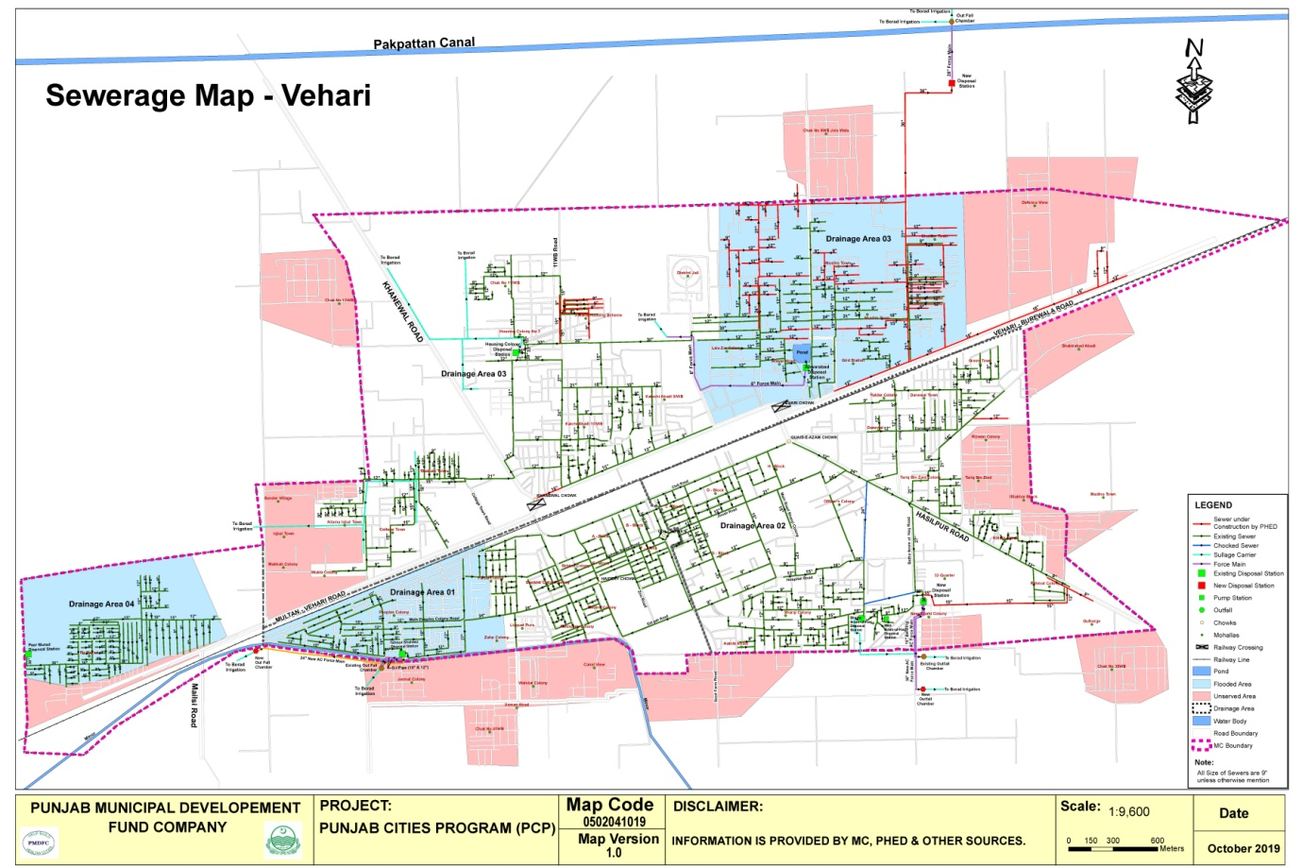

### **Existing pumping / disposal stati**ons

The detail of each pumping station already working in the city is given below;

|  |  |  |  |  |  |  |  |  |  |  |
| --- | --- | --- | --- | --- | --- | --- | --- | --- | --- | --- |
| **Location** | **Nos of collect. tanks** | **Nos of pumps** | **Discharge each (cusecs)** | **Total discharge (cusecs)** | **Motor BHP** | **working status** | **Force main/S. Carrier** | | | **Ultimate disposal** |
| **Size** | **Length** | **Condition** |
| Anwar abad | 1 | 1 | 1.0 | 1.0 | 20 | working | 9” dia | 1.5km | Good | Broad irrigation |
| Bhatta IkramulHaq (main) | 2 | 3 | 2.0 | 6.0 | 40 | 01 No working | 12” RCC pipe & SC | 1.0 km | poor | do |
| BhattaI kmraulHaq mini | 1 | 1 | 1.0 | 1.0 | 20 | working | 6” dia | 0.18km | Good | do |
| Tamoor Shaheed Colony | 3 | 4 | 4.0 | 16.0 | 50,50,60,60 | working | 10’, 12” & 24” dia | 2.0 km | Good | do |
| Housing Colony | 2 | 4 | 5.0 | 20.0 | 60 | 2 Nos. working | Sullage carrier | 2.62km | Fair | do |
| 32 Quarter | 2 | 3 | 4.0 | 12.0 | 50 | working | 16” & 36” | 2km | Poor | do |
| Peer Murad | 1 | 2 | 1.0  0.5 | 1.5 | 20  10 | 01 No working | Sullage carrier | 100 ft | good | do |
| New disposal station | 2 | 5 | 5.0 | 25 | 60 | Working | 28” dia | 500 ft | good | do |

### Sucker & jetting machines

01 No sucker and 01 No jetting machines are being used by MC to remove blockades and cleaning of sewers. The sucker and jetting machines are quite old and require repairs along with supply of required pressure pipe for jetting machine.

### Man power deployed

The manpower deployed presently for the operation & maintenance of the system is given below against the total regular strength of 27 persons.

|  |  |
| --- | --- |
| Pump operators | 2 |
| Baildars | 0 |
| Supervisors | 2 |
| Sewer men | 23 |
| Total | 27 |

MC is demanding additional manpower because of increase in population as they are serving those areas in the city which are not included within the municipal boundary.

### Tariff structure

All the sewer connections are not being charged. Only 6000 Nos. connections are being charged at the rate of Rs 240 per annum.

The service charges levied for the liquid waste management are very nominal and the collection of the revenue is not giving any attention neither by the key officers nor by the public representatives

### Drainage zones

The city has been divided in 4 zones with respect of the waste water drainage. Each zone with its coverage is described below;

1. **Zone-1**

This zone comprises of the areas lying in the south of the railway track. Two trunk sewers of 21” dia and 27”dia collect the waste water from these areas and discharge in Taimoor Shaheed disposal works. All branch and lateral sewers in mohallahs of Peoples Colony, Zafar Colony, Liaqatpura, Faisal Colony, Rehmania Colony, Madina Colony, Sheikh Cotton Colony, Sirhind Colony, A,B,E & F blocks have been connected to these outfall sewers. Waste water from Taimoor Shaheed disposal station is disposed-off for broad irrigation into an outfall sump through two DI force mains of 10” and 12” diameter.

PHED has laid a new force main of 24” dia AC pipe and the water is now being dispose-off in two separate outfall sumps through three force mains.

1. **Zone-2**

This zone comprises of areas lying in the south of the railway track and is drained off into 32-Quarter and Bhatta Ikramul Haq disposal works. The disposal works Bhatta Ikramul Haq is quite old and collecting waste water by 24” & 18” dia. trunk sewers. The waste water is being disposed-off for broad irrigation through 16” RCC pipe and finally by sullage carrier. The disposal works 32-Quarter is collecting waste water by 33” & 36” dia. trunk sewers. The waste water is being disposed-off for broad irrigation through existing 16” dia AC force main and recently laid 36” dia AC force main. The areas named as C, D, G, H blocks, Officers Colony, DHQ Hspital, Sharqi Colony, New Sharqi Colony, Bhatta Ikramul Haq, 32-Quarter, Rehamtabad, Kachiabadi, Tariq Bin Zaid Colony, Haider Colony and Danewal Town are connected with Drainage area-2.

1. **Zone-3**

This zone of comprising of three disposal works as given below;

1. **Disposal work Housing Colony**

This areas is lying in the North of the railway track and is drained off into Housing Colony disposal works which is discharging waste water for broad irrigation through sullage carrier along the Khanewal road.

1. **Anwarabad Disposal station**

Another small disposal station is working in Anwarabad which is only draining a pond and disposing-off water in fields for broad irrigation. This is not connected with any sewerage system.

1. **New disposal station**

PHED Vehari has constructed a disposal station in the northern area with outfall sewer of 36”diaand 28” force main. This disposal works has been constructed to remove the waste water flooding in the eastern areas of the existing housing colony disposal works system for which new sewers have been laid to take of the load from that system. Some existing sewers have also been connected with newly laid sewers and the system is being operated for last so many month.

Both the disposal works in this zone are serving the areas of Ghafoor Colony, Muslim Town, Anwar abad, LalaZar Colony, 3-Marla Scheme, Housing Scheme, Chak 11/W.B, KachiAbadi, Iqbal town, College town, Stadiun town and Wukla Colony.

1. **Zone-4**

This zone comprises of areasof Peer Murad Colony lying in the North of the railway track at western side of the city and is drained-off into Peer Murad disposal works through a trunk sewer of 36” dia. The waste water is being disposed-off for broad irrigation through sullage carrier.

### Sewer lengths

The approximate length of old sewers is given below;

|  |  |  |  |  |  |  |  |  |
| --- | --- | --- | --- | --- | --- | --- | --- | --- |
| Sewer dia. (inch) | **9** | **12** | **15** | **18** | **21** | **24** | **27** | Total length  in Km |
| Length in Km | 20 | 8.0 | 3.0 | 4.0 | 2.0 | 4.0 | 2.0 |
| Sewer dia (inch | **30** | **33** | **36** |  |  |  |  | 47.5 Km |
| Length in Km | 2.0 | 1.5 | 1.0 |  |  |  |  |

## Streetlight

MC Vehari has street lights on major roads and Mohallahs

### Streetlights on Major roads:

Some roads in the city have been provided with street light. The detail of these installations is given below;

|  |  |  |  |  |
| --- | --- | --- | --- | --- |
| S.N. | Name of Road/Street | From To | No. of  Lights | Installed/ not installed |
| 1 | Ludden Road | Quaid e Azam Chowk to Bhatta Shadi Khan | 48 | Installed |
| 2 | Multan Road | Khanewal Chowk to Peer Murad Road | 50 | Not installed |
| 3 | Purana Lorry Adda Road | Khanewal Chowk to V-Chowk | 88 | Installed |
| 4 | Burewala Road | V Chowk to new Sabzi Mandi | 90 | Installed |
| 5 | Jinnah Road | DPO House to Fire Brigade | 24 | Not installed |
| 6 | Club Road | Quaid-e-Azam Chowk to Masjid Bagh wali | 56 | Not installed |

### Ward wise detail of existing streetlights

Energy saver bulbs are being used instead of LED lamps which are fulfilling the requirements in different Mohallas.

|  |  |  |  |  |  |  |
| --- | --- | --- | --- | --- | --- | --- |
| **Ward No** | **Area** | **Type of light** | | **Total** | **Operational Status** | **Pole type used** |
| **LED Bulb (30 Watt)** | **LED 12,20,24 Watt** |
| 1 | Chak No/11, Girls School Makkah Town | 5 | 12 | 17 | 8 | WAPDA pole |
| 2 | Qari Latif wala Mohala, Muhammadi Baikri | 15 | 35 | 50 | 27 | WAPDA pole |
| 3 | Katholik church road murtazaabadMohallahJogian | 12 | 20 | 32 | 12 | WAPDA pole |
| 4 | Baba Pan Shop, Mohallah Shamsh Masjid | 18 | 30 | 48 | 24 | WAPDA pole |
| 5 | Mohallah Rana Shah Muhammad, old Lorri Adda | 23 | 55 | 78 | 37 | WAPDA pole |
| 6 | Madina Hospital Road, Changer Mohallah, Ouncha Mohallah | 10 | 30 | 40 | 16 | WAPDA pole |
| 7 | Basti Khjoor wali, Masjid Zaki Shaha | 22 | 38 | 60 | 35 | WAPDA pole |
| 8 | Androon Kachari Road, lalazar colony | 11 | 20 | 31 | 15 | WAPDA pole |
| 9 | Anwar abad, Muslim Town | 22 | 34 | 56 | 27 | WAPDA pole |
| 10 | Rizwan Colony, Tariq bin zyad Colony, Daniwal | 50 | 146 | 196 | 89 | WAPDA pole |
| 11 | Rehamat Colony, Bhatta Shadi Khan | 110 | 138 | 248 | 115 | WAPDA pole |
| 12 | BhattaI kramulhaq, H block | 23 | 64 | 87 | 45 | WAPDA pole |
| 13 | Masani Bagh, Sharqi Colony | 112 | 134 | 246 | 101 | WAPDA pole |
| 14 | D Block, G Block | 120 | 180 | 300 | 158 | WAPDA pole |
| 15 | A Block, B Block, C Block | 12 | 47 | 59 | 32 | WAPDA pole |
| 16 | E Block, Madina Colony | 130 | 164 | 294 | 179 | WAPDA pole |
| 17 | Liaqat Pura | 21 | 127 | 148 | 94 | WAPDA pole |
| 18 | Chamara Mandi, Sheikh Cotton Colony, Faisal Colony | 25 | 65 | 90 | 42 | WAPDA pole |
| 19 | X Block | 28 | 70 | 98 | 47 | WAPDA pole |
| 20 | Zafar Colony, Y Block | 22 | 35 | 57 | 33 | WAPDA pole |
| 21 | Z Block, W Block | 23 | 94 | 117 | 59 | WAPDA pole |
| 22 | V Block, U Block | 25 | 50 | 75 | 32 | WAPDA pole |
| 23 | Peer Murad Colony | 5 | 7 | 12 | 3 | WAPDA pole |
| 24 | Iqbal Town, College Town | 25 | 45 | 70 | 24 | WAPDA pole |
|  | **Total** | **869** | **1640** | **2509** | **1254** |  |

# Complaint Management

Municipal Committee Vehari has established a centralized complaint cell for complaints registration, its tracking and resolution. The primary objective of establishing complaint cell was to enhance MC’s efficiency in addressing citizens’ and building confidence of citizens.

The complaint cell has been provided with telephone line to facilitate the complaint registration over the phone without walking in to the office. Every complaint, whether received in writing or verbally, is recorded in the software by a designated complaint cell in charge. Each recorded complaint generates a unique number already printed on the complaint slip. The complainant also receives the complaint number for the follow up, if required. Once the complaint is resolved by the relevant staff, he returns his part of the complaint slip to the complaint cell with his remarks and the complaint cell in charge updates the status of complaint in the software accordingly. The complainant may inquire the status of his complaint at any time just by calling the complaint registration office with reference to his complaint number. This process ensures the registration and tracking of all the complaints, thus keeping MC staff accountable to the MC management as well as the citizens.

|  |  |  |
| --- | --- | --- |
| Complaints: Received Summary Year – 2021-22 | | C:\Users\Naveed\Downloads\WhatsApp Image 2020-11-20 at 10.51.00 AM.jpeg |
| Sector | **Complaints** |
| Water Supply | **3%** |
| Sewerage and Drainage | **81%** |
| Streetlight | **17%** |
| Solid waste | **15%** |
| Percentage Resolved | **96%** |

# MC Website

(www.mcvehari.lgpunjab.org.pk)

Municipal Committee Vehari has also developed its website for dissemination of information for general public. The information contain all major categories of information for citizen’s interest like information about the officers with their telephone numbers, budget detail, Development projects, news and events

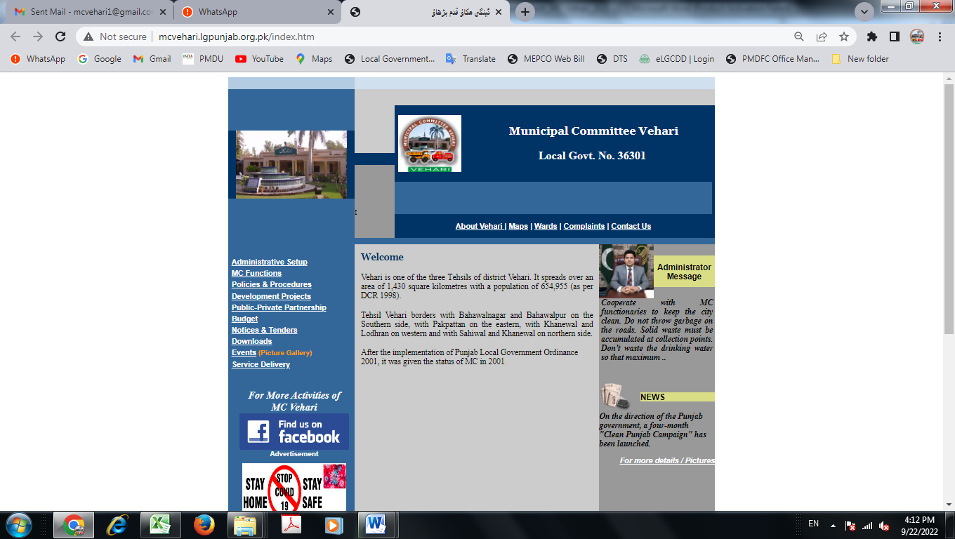

# MC Response to the Requests of Citizens under RTI Act 2013

No request received from any citizen during the current year

**SUMMARY OF RESPONSE TO CITIZENS REGARDING RTI REQUESTS**

**(2021-22)**

|  |  |  |  |  |  |  |  |  |  |
| --- | --- | --- | --- | --- | --- | --- | --- | --- | --- |
| **MC Section** | **No. of Requests Received** | **No. of Requests Attended** | **Average No. of Days/ Time span to Attend Request** | **No. of Requests Refused/ Not Fit for Sharing Information** | **No. of Requests Forwarded to Other Departments for Seeking Information** | **Total No. of Requests In Progress** | **Total No. of Requests Pending** | **Citizen’s Satisfaction Feedback** | **Remarks** |
| Chief Officer | x | x | x | x | x | x | x | x | x |
| MO( I&S) | x | x | x | x | x | x | x | x | x |
| MO (F) | x | x | x | x | x | x | x | x | x |
| MO (P) | 3 | 3 | x | 03 | 0 | 0 | 0 | Satisfactory | x |
| MO (R) | x | x | x | x | x | x | x | x | x |
| **Total** | x | x | x | x | x | x | x | x | x |

# Annex A

**Human Resource Detail**

| **Sr.No** | **Designation** | **BPS** | **Strength as per Approved SOE** |
| --- | --- | --- | --- |
|
|  | **Chairman /Vice Chairman** |  |  |
| 1 | Chairman | fixed | 1 |
| 2 | Junior Clerk/Telephone Operator | BS-11 | 1 |
| 3 | NaibQasid | BS-01 | 1 |
| 4 | Vice Chairman | fixed | 1 |
| 5 | NaibQasid | BS-01 | 1 |
| **Total** | | | **5** |
|  | **Chief Officer** |  |  |
| 6 | Chief Officer | BS-18 | 1 |
| 7 | Office Superintendent | BS-17 | 1 |
| 8 | Junior Clerk | BS-11 | 1 |
| 9 | Senior Clerk (Record Keeper) | BS-14 | 1 |
| 10 | Senior Clerk (Agenda) | BS-14 | 1 |
| 11 | Computer Operator | BS-12 | 1 |
| 12 | English Typist | BS-05 | 1 |
| 13 | Patwari | Part Time | 1 |
| 14 | Driver | BS-05 | 1 |
| 15 | NaibQasid | BS-01 | 6 |
| 16 | Baildar | BS-01 | 1 |
| 17 | Chowkidar | BS-01 | 1 |
| **Total** | | | **17** |
|  | **Municipal Officer Planning** |  |  |
| 18 | **Municipal Officer (Planning)** | BS-17 | 1 |
| 19 | Assistant Architect | BS-17 | 1 |
| 20 | Assistant (Head Clerk) | BS-16 | 1 |
| 21 | Building Inspector | BS-14 | 1 |
| 22 | Sub Engineer | BS-11 | 1 |
| 23 | Draftsman | BS-12 | 1 |
| 24 | Junior Clerk | BS-11 | 2 |
| 25 | NaibQasid | BS-02 | 1 |
| 26 | Driver | BS-05 | 1 |
| **Total** | | | **10** |
|  | **Municipal Officer Finance** |  |  |
| 27 | **Municipal Officer (Finance)** | BS-17 | 1 |
| 28 | Accountant | BS-14 | 1 |
| 29 | Senior Clerk/Accounts Assistant | BS-14 | 1 |
| 30 | Accounts Clerk | BS-15 | 1 |
| 31 | Senior Clerk(Pension) | BS-14 | 1 |
| 32 | NaibQasid | BS-01 | 2 |
| **Total** | | | **7** |
|  | **Revenue Branch** |  |  |
| 33 | Assistant (Tax Superintendent) | BS-14 | 1 |
| 34 | Senior Clerk | BS-14 | 1 |
| 35 | Senior Clerk (Tax Inspector) | BS-14 | 2 |
| 36 | Junior Clerk | BS-11 | 3 |
| 37 | Junior Clerk (Tax) | BS-11 | 1 |
| 38 | Junior Clerk (Water Rate) | BS-05 | 2 |
| 39 | NaibQasid | BS-01 | 1 |
| **Total** | | | **11** |
|  | **Municipal Officer Regulation** |  |  |
| 40 | **Municipal Officer (Regulation)** | BS-17 | 1 |
| 41 | Assistant (Head Clerk) | BS-16 | 1 |
| 42 | Junior Clerk | BS-11 | 2 |
| 43 | Driver | BS-05 | 1 |
| 44 | NaibQasid | BS-01 | 5 |
| 45 | Baildar | BS-01 | 1 |
| **Total** | | | **11** |
|  | **KatchiAbadi** |  |  |
| 46 | Assistant (Head Clerk) | BS-16 | 1 |
| 47 | Senior Clerk | BS-14 | 1 |
| 48 | Junior Clerk | BS-11 | 1 |
| 49 | NaibQasid | BS-01 | 1 |
| **Total** | | | **4** |
|  | **Law Branch** |  |  |
| 50 | Legal Advisor | Part Time | 1 |
| 51 | Assistant (Perokar) | BS-14 | 1 |
|  | | | **2** |
|  | **Municipal Officer Infrastructure** |  |  |
| 52 | **Municipal Officer Infrastructure** | BS-17 | 1 |
| 53 | Sub Engineer | BS-11 | 3 |
| 54 | Assistant (Head Clerk) | BS-16 | 1 |
| 55 | Junior Clerk | BS-11 | 2 |
| 56 | Driver | BS-05 | 1 |
| 57 | Driver (Road Roller) | BS-05 | 1 |
| 58 | Work Mistry | BS-03 | 1 |
| 59 | NaibQasid | BS-01 | 2 |
| **Total** | | | **12** |
|  | **TRANSFPORT TERMINAL** |  |  |
| 60 | Assistant (Adda Incharge) | BS-14 | 1 |
| 61 | Junior Clerk (Time Keeper) | BS-05 | 1 |
| 62 | Naib Qasid | BS-01 | 1 |
| **Total** | | | **3** |
|  | **PARKS & GARDENS** |  |  |
| 63 | Assistant Floricultural Supervisor | BS-05 | 1 |
| 64 | Baildar | BS-01 | 27 |
| 65 | Chowkidar | BS-01 | 2 |
| **Total** | | | **30** |
|  | **Municipal Officer Services** |  |  |
| 66 | **Municipal Officer Services** | BS-17 | 1 |
| 67 | Assistant (Incharge Sanitation) | BS-14 | 1 |
| 68 | Senior Clerk (NaibIncharge Sanitation) | BS-14 | 1 |
| 69 | Junior Clerk | BS-11 | 1 |
| 70 | NaibQasid | BS-01 | 1 |
| 71 | Driver | BS-05 | 18 |
| 72 | Sanitary Supervisor | BS-05 | 7 |
| 73 | De-Watering Operator | BS-02 | 1 |
| 74 | Plague Quli | BS-01 | 1 |
| 75 | Cleaner | BS-01 | 1 |
| 76 | Sanitary Worker | BS-01 | 198 |
| 77 | Water Carrier | BS-01 | 16 |
| 78 | Sewer men | BS-01 | 16 |
| **Total** | | | **263** |
|  | **Slaughterhouse** |  |  |
| 79 | Superintendent Slaughterhouse | Part Time | 1 |
| 80 | Chowkidar | BS-01 | 1 |
| 81 | Water Carrier | BS-01 | 1 |
| **Total** | | | **3** |
|  | **FIRE BRIGADE** |  |  |
| 82 | Assistant Superintendent Fire Brigade | BS-12 | 1 |
| 83 | In-charge Fire Station | BS-10 | 1 |
| 84 | Head Fire man | BS-08 | 3 |
| 85 | Fire man | BS-05 | 12 |
| 86 | Driver | BS-07 | 6 |
| **Total** | | | **23** |
|  | **LIGHT BRANCH** |  |  |
| 87 | Light Superintendent | BS-17 | 1 |
| 88 | Electrician | BS-07 | 1 |
| 89 | Electric Quli | BS-01 | 1 |
| **Total** | | | **3** |
|  | **WATER WORKS BRANCH** |  |  |
| 90 | Water Works Superintendent | BS-17 | 1 |
| 91 | Plumber | BS-05 | 1 |
| 92 | Tube Well Operator | BS-05 | 15 |
| 93 | Tube Well Operator cum Chowkidar | BS-03 | 16 |
| 94 | Fitter Quli | BS-01 | 3 |
| 95 | Baildar | BS-01 | 6 |
| 96 | Chowkidar | BS-01 | 3 |
| **Total** | | | **45** |
|  | **DISPOSAL WORKS BRANCH** |  |  |
| 97 | Disposal Operator | BS-05 | 1 |
| 98 | Disposal Operator | BS-03 | 9 |
| 99 | Chowkidar | BS-01 | 1 |
| **Total** | | | **11** |
|  | **Library Branch** |  |  |
| 100 | Librarian | BS-17 | 1 |
| 101 | Head Clerk | BS-16 | 1 |
| 102 | Junior Clerk | BS-11 | 2 |
| 103 | NaibQasid | BS-01 | 2 |
| 104 | Chowkidar | BS-01 | 1 |
| **Total** | | | **7** |
| **G. Total** | | | **467** |

# Annex C

**MC Vehari - List of Approved Projects 2021-22**

| **Sr. No** | **Name of Project** | **Gestation Period** | **Approved Cost  (PKR)** | **Status** | **Physical Progress  (%)** | **Remarks** |
| --- | --- | --- | --- | --- | --- | --- |
| **Year 2020-21** | | | | | | |
|  | Frame contract for damage sewer lines, raising / repairing of manholes, Covers, slabs, Gully Grating, PVC pipe line etc. City Area. MC Vehari for FY. 2021-22 | 01-09-2021 | 30,00,000 | Completed | 100% |  |
|  | Construction Of Tuff Tile Street Zafar Iqbal Faisal Town Near Faisal Park Vehari | 29-12-2021 | 1,99,400 | Completed | 100% |  |
|  | Construction Of Tuff Tile Chowk Main Gate Faisal Park Green Belt. | 29-12-2021 | 1,66,000 | Completed | 100% |  |
|  | Construction Of Side Wall Al-Halal Hockey Club Ex-Plate Form Vehari. | 29-12-2021 | 1,99,000 | Completed | 100% |  |
|  | Construction, Extension Plate Form (Flooring) Al-Halal Hockey Club “F” Block Vehari | 29-12-2021 | 1,99,900 | Completed | 100% |  |
|  | Construction Of Sewer Line Bhatta Shadi Khan Luddan Road Vehari. | 29-12-2021 | 1,99,800 | Completed | 100% |  |
|  | Construction/Repair, White Washing/Painting Quarter Naveed Amjad Qadri Municipal Employees Colony “G” Block Vehari. | 29-12-2021 | 1,73,000 | Completed | 100% |  |
|  | Providing And Installation Water Supply Pipe Line Saith Arif Joyia Wali Street Ward No.8 | 29-12-2021 | 1,34,000 | Completed | 100% |  |
|  | Construction Of Soling Street Mehboob Alam Wali Lalazar Colony Vehari. | 29-12-2021 | 1,99,000 | Completed | 100% |  |
|  | Construction Of Soling Basti Darbar Wali Sajid Hussain Lalazar Colony Vehari | 29-12-2021 | 1,97,500 | Completed | 100% |  |
|  | Construction Of Soling Charch Wali Street Near Fish Pound Christen Colony Muslim Town. | 29-12-2021 | 1,96,000 | Completed | 100% |  |
|  | Construction Of Tuff Tile Street Jamia Masjid Madrassa (Hassan Bin Sabit) Allama Iqbal Park And Street No.6 Madrassa Campus Markaz Dar-Al-Ahsan Lala Zar Colony Vehari. | 29-12-2021 | 1,60,000 | Completed | 100% |  |
|  | Construction of soling dr. Zaffar masjid ayesha wali street muslim town vehari | 29-12-2021 | 1,45,000 | Completed | 100% |  |
|  | Construction of soling, re-soling, rauf jutt wali and ch. tahir arain wali street lalazar colony vehari. | 29-12-2021 | 1,68,000 | Completed | 100% |  |
|  | Construction Of Soling “G” Block Street Sulman Kathia Wali Mc Vehari. | 29-12-2021 | 1,97,500 | Completed | 100% |  |
|  | Construction Of Soling Luddan Road Back Side Kips College Mc Vehari. | 29-12-2021 | 1,98,000 | Completed | 100% |  |
|  | Construction Of Tuff Tile Street Masjid Al-Fareed Lalazar Colony Mc Vehari. | 29-12-2021 | 1,99,000 | Completed | 100% |  |
|  | Purchase of Manhole Covers (Emergency Work) for Unit Vehari District Council Vehari | 20-06-2022 | 29,90,100 | Completed | 100% |  |